Get Results, Make Positive Impact:
Results Based Accountability Training Worksheet
Use this and your RBA Guide to support your learning throughout the training.

PRACTICE: GETTING CLEAR ON RESULTS LANGUAGE
What’s the idea? | What does RBA call it? | What does my organization call it?
A statement about the condition of well-being that you are seeking. | Result
A measure which helps to quantify the achievement of a result. | Indicator
A quantifiable measure of how well a strategy/agency/system is working. | Performance Measure
The wellbeing of the WHOLE population, such as communities, cities, counties, states, or nations. | Population Level Accountability
The wellbeing of the CLIENT population, such as in a program, agency, or service system. | Performance Level Accountability

PRACTICE: POPULATION LEVEL ACCOUNTABILITY
What groups are being left behind that you want to impact? ____________________________________________________________________________________________________________________

Draft one or two results statements you could use at your organization, group, coalition. Remember, a results statement is a complete outcome statement about the condition of well-being that you seek. For example: All ______ (population) in ______ (geographic area) are __________ (statement of well-being).
____________________________________________________________________________________________________________________
__________________________________________________________

PRACTICE: SELECTING INDICAORS
What types of data do you have available? What new data might you access?
Criteria for Indicators:
- Communication Power – communicates well at all levels and is understood in the “public square”
- Proxy Power – says something of central importance to the result; brings other data along
- Data Power – quality data is available on a timely basis; available at both state and county level
Choose 1-2 indicators to rate. Then rate the indicators as High (H), Medium (M) or Low (L) based on the criteria described above.

Candidate Measures | C | P | D | Notes and Comments (e.g. new or existing, where to find it)

Highest scoring measure:
____________________________________________________________________________________________________________________

PRACTICE: PERFORMANCE LEVEL ACCOUNTABILITY
Write your organization’s Performance Measures in the matrix below, placing each measure in the quadrant most relevant. Do they fall most heavily in one quadrant? Which of these are you paying the most attention to?
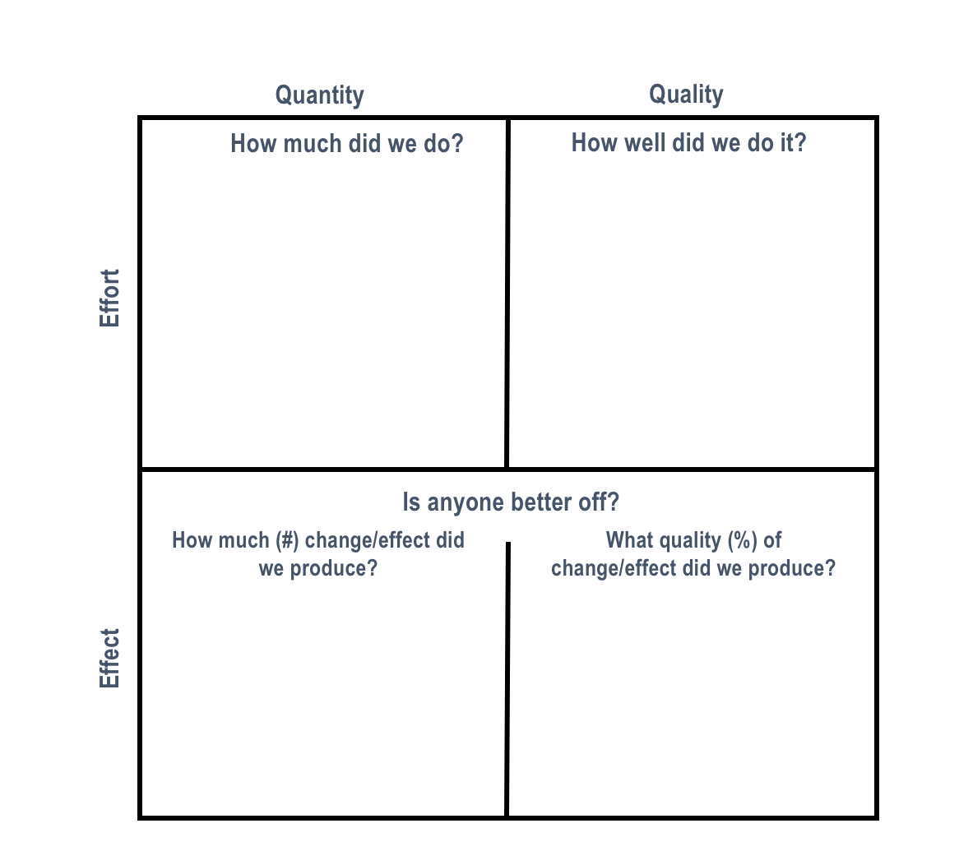

PRACTICE: TURN THE CURVE
Write your notes on Turn the Curve

What is the story behind the curve?
Why is this data trend occurring?

How are we doing?
Based on indicator baseline data, where are we headed (assuming no changes are made)?

Indicators
A measure which helps quantify the achievement of a result.

Result
A condition of well-being for a specific population or community. What are you hoping to achieve?

Root Causes
List in order of priority, the root causes influencing the “curve” of the baseline.
_________________________ _________________________
_________________________ _________________________
_________________________ _________________________
_________________________ _________________________

Who are partners who might have a role to play in turning the curve?
List potential partners and, if known, the role(s) they might play.
Partners | Role

What would work to turn the curve?
Place your ideas on the map according to its relative difficulty to implement (easy/hard) and potential impact (high/low).

Difficulty
Easy
Hard

Impact
Low
High

PRACTICE: BRING IT ALL TOGETHER

How can a results-driven mindset change or improve how you do your work?
____________________________________________________________________________________________________________________
____________________________________________________________________________________________________________________
____________________________________________________________________________________________________________________
____________________________________________________________________________________________________________________

What part of this training was most exciting to you? How might you bring that back to your organization, group, coalition?

____________________________________________________________________________________________________________________
____________________________________________________________________________________________________________________
____________________________________________________________________________________________________________________
____________________________________________________________________________________________________________________

What is one thing you learned that you will take back with you?
____________________________________________________________________________________________________________________
____________________________________________________________________________________________________________________
____________________________________________________________________________________________________________________
____________________________________________________________________________________________________________________

