aTTENDANCE  Michelle Sturm, Elizabeth Parmelee, Jeri Ajayi, Treloar Bower, Gerald Hamel, Bithiah Coleman, Chuck Ault, Kellie Teter, Emily Holcomb  next meeting  - July 1 5:30 – 7 Movement Makers Action Team  - July 2 5-6 East5ide Café – Informational meeting at 3532 N Franklin, Suite H  - July 8 finance and governance  - July 10 5:30 – 7:30 Community council meeting  - July 29 – 5- 8 pm Anchors and Council event @ Metro Caring | Intention  To explore and build an understanding of what Anchor Institution work really is and means, moving from conceptual to concrete, in order to contribute to the field with a focus on the intersects between early childhood, family friendly policies, business development and Anchor Institutions.  Introductions – Name, organization, biggest Aha of the week  - Consider our language and how what we say either opens or limits our thinking – primes us to certain ideas  Objectives:  - Approved draft budget for Year 2  - Clear direction on path of this group  OPening – Taking Stock  East5ide – what is it exactly?  Anchor Missions – what are they exactly?  East5ide Anchors – how do they play together?  This space as a playground for investigating Anchor type activities  Take a moment –Highlight what you see in the document that sticks out to you, that seems aligned, seems out of order.  On third page – how do we achieve the outcome of anchor missions? We need the HOW, and see the gap to brigde. We need to seem our intended outcomes to try to get to our intended outcome  Want to look at how we are actualy contributing to the field – what tools, what our outcome is, what our improvements in data are  Overlap in East5ide mission – we work to influence the community around us. We are toally aligned in this, the how and what details may differ  Sometimes feel bogged down by the reference to early childhood – so I zoom out and think if my org implemented X, it would be good for families  How do we hone in on the “right way” do describe the work  Suggestion – looking at the $ on slide 4. Seeing large amount of $ and limits on Medicaid cases able to take and end up only getting high quality care when in emergency because they can’t get in for routine care  Have a pot of $ at beginning of year and know how many patients we can cover. Some of it is # of patients, and some of it is geography based since complex cases may take more of the pot and therefore limit #  Denver health is a true safety net where no one is turned away. Other hospitals regularly turn people away yet still call selves safety net. How can we get a different deal for true safety nets (more $ for more #)  Loop this slide back – it is designed to get you to think about the scale of influence these hospitals and institutions could have if they used their $ in such a powerful way. By changing how we invest, we invest in people and create better systems and outcomes. People employed by hospital get commercial healthcare, taken out of the medicare pool, and someone else slots in to that medicare slot  Local hiring – locals still aren’t being hired at measurable rates. Local hire office has control until the point of hire  The one trillion $ is about their spend in general, not on healthcare or hiring – look at how much could be invested back into community  where are we now  Learning or doing – favoring middle to the do  Spend time now thinking about big buckets of learning  Once there are tasks, deliverables, staff time, tha  lt is doing. Simply hearing about (possibly to later inform work) is learning.  Learning is building capacity, doing is action based on a need  What activities will support our or our community’s capacity?  Connect with the Denver Anchor Netowrk to connect people to on the ground work, use our $ to bring big events/people here  Partner with big organizations to have  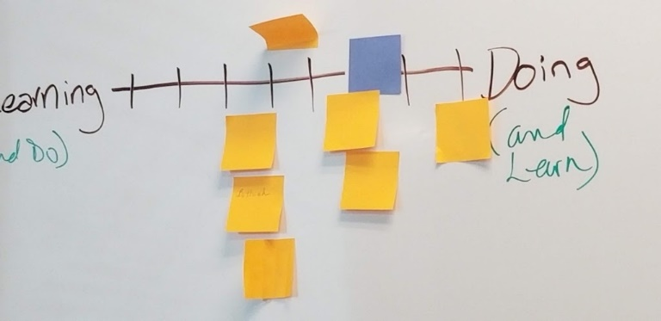  budgeting for yr2  Working with $100,000  Small amount allocated to Rose to support Kellie and Chuck with administrative work  Interested in allocating $ to a dedicated facilitator $20k per year  100K  -20k to facilitation and meetings  - 25k Learning – training – speakers  - community engagement  - project execution  TA Plan  Developed through survey and 1:1 with Jodi Drisko  Vital next steps & Announcements  Key questions  How could there be more Medicaid slots at hospitals than Denver Health?  There is a knoweable amount for charity care and free admissions – how do we communicate this?  What is the best way to describe the scale of this work?  Like this concept – how do we reframe issues  How do we create economic opportunity so there are less people on Medicaid  Ensure we consider the fact inequality is growing, so the way we do our work anticipates that outcome  What are the 80205 outcomes we seek? What are the steps?  Recurring meeting option – 4th Friday?  July event  August – Caila BAR and AAR  Future  Consider deeper work in framing (Frameworks Institute)  Chuck, Kellie, others share the things they are doing (housing, wages)  Template – as a part of the agenda, share about initiative  Who is a part of this group – what is ANCHOR  +

