# East5ide Unified|Unido Network Map

## Network Mapping

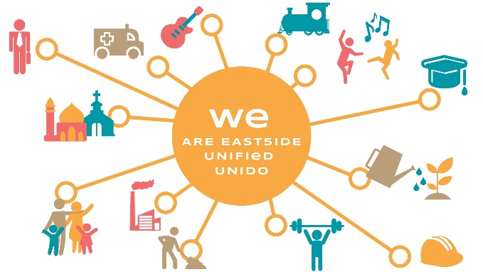Network mapping is the process of identifying and capturing the individuals, organizations, connections and relationships within a network. This visual representation of a network offers an opportunity to better understand the network’s the dynamic and complex nature.

East5ide Unified|Unido uses network mapping to visually represent our growing network and the relationships between individuals, organizations and programs dedicated to the health and success of young children and families in NE Denver. This visual representation will continue to help us understand important partnerships, track participation, and communicate our story.

## Background

In 2017, during the BUILD Health Grant Implementation Round, East5ide Unified|Unido sought to deepen our understanding, and increase coordination and cooperation between organizations, people and programs that care about the health of young children and families in northeast Denver.

In 2018, East5ide Unified|Unido hosted a community gathering, [The 80205 Summit](https://mailchi.mp/5b1b7d3831fb/invite-1-80205-unity-summit-979433), for current and new community members and organizations that felt a connection with the work and mission of East5Ide Unified|Unido. During registration participants were asked about their area of focus (ex. Healthy Eating Active Living, Economic Development, Safety, Early Childhood Development, Physical/Mental Health, etc.) and to identify up to 5 of their key partners. The Evaluation and Learning Work Group produced an initial network map that was presented at the community event. At 80205 Summit, participants divided into groups based on focus areas to review, edit and reflect on the preliminary maps. Over 200 new connections were identified during the event.

|  |  |  |
| --- | --- | --- |
| Results of the mapping activity at the 80205 Summit | | |
| cid:Resized_Fatherhood_53078984826208 | cid:Resized_Built_Environment_53078741460687 | cid:Resized_Early_Childhood_53016089531440 |

After the event, the Network Map was updated and shared with all the stakeholders who participated in the 80205 Summit. The East5ide Unified|Unido Network Map is available [here](https://kumu.io/meghanchaney/80205-network-map#map-1JMwf1Th).

## New Resources and Opportunities

Since the 80205 Summit, East5ide Unified|Unido decided to use the online platform [Civic Network](https://www.civicnetwork.io/) to share documents, track events, and manage our network. Recently, Civic Network partnered with Kumu to integrate a [Network Map feature](https://www.civicnetwork.io/network-map) capable of creating maps of individual initiatives as well as visualizing the larger network connected to Civic Network. East5ide Unified|Unido sees this new resource as a more sustainable method for updating our network map.

East5ide Unified|Unido will optimize use of Civic Network in 2019. The dynamic platform will serve as [an East5ide Unified|Unido Hub](https://www.civicnetwork.io/network/east5ide-unified) for new and current users to share and engage with each other. The new Kumu feature will allow East5ide Unified|Unido to automatically capture the growing network and use the information collected to plan action, make decisions and share their community.

On Civic Network our current map is represented [here](https://embed.kumu.io/2e79a4288fd8516a62847546cea2dfa0#the-network/n-136?focus=1).

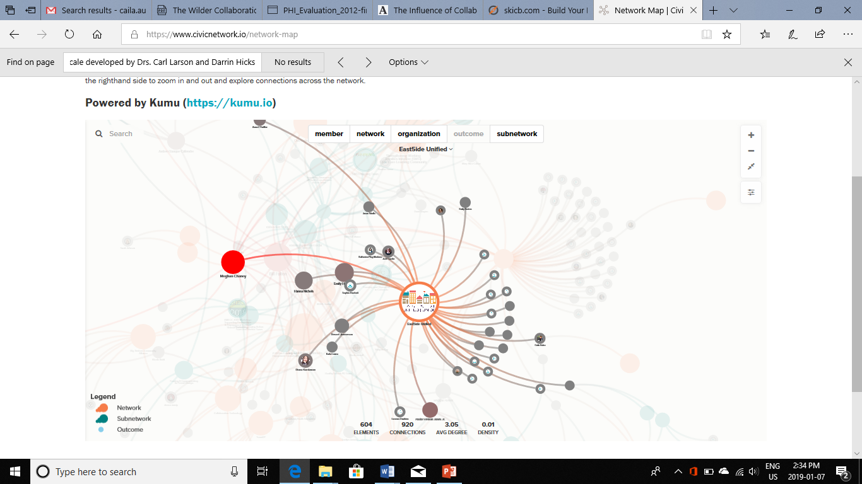

## Next Steps

* Continue to encourage current EU members and associates to [connect on Civic Network](https://www.civicnetwork.io/node/136/join?code=1481736353-136)
* Develop an orientation and invitation structure that supports new individuals and organizations to connect to EU activities, outcomes and network map.
* Develop a method for individuals who can’t access Civic Network to be integrated into the network map
* Explore if EU will use its network map to display and highlight Community Asset Mapping results
* **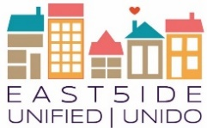**Annually reflect on EU network map to support decision making and storytelling.