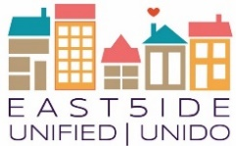

Evaluation and Learning Action Team Notes.
East5ide Unified|Unido CDPHE grant Evaluation Questions:
- To what extent are Anchor Institutions implementing FFP?
- To what extent are relationship between and within community members, institutions and businesses associated with EU changing?
- To what extent is EU's process contributing to authenticity, trust and cohesion?
- To what extent is 80205 a community that supports families and children based on EU's identified indicators of success?
Location: The Civic Canopy
Date: February 21st, 2019

- Round table and updates
We will start saving meeting and tools on the Civic Network. Evaluation and Learning has a subnetwork on the EU page.
    - Civic Network Results: https://www.civicnetwork.io/node/136/results
    - Civic Network ELT: https://www.civicnetwork.io/network/east5ide-unified-unido-learning-and-evaluation-action-team

  - Data Collection progress
    - Collaboration Process Survey will go out next week. The survey is being translated. This survey will help to answer evaluation #3. We are asking all EU members (action meet, council, folks engaged community meetings) to participate. Survey will close March 15th. Results will be shared back in April. Caila will run a preliminary analysis and during an action team meeting we will do some interpretation and plan how to share back with the larger group.

    - Anchor Institution Assessment: The AI action team has contracted with a local expert to develop an Anchor Institution Assessment. The hope is to have each anchor institution complete the assessment by May and use the information to inform a learning session with the institutions, led by a member of our team, in the summer.

    - Caila is reaching out to Lorenzo, a local artist, to support the storytelling activity. This activity will support answering question #2 and provide some insight into question 3. The storytelling activity will consist of 2 parts: 1: creatively engage folks in collecting stories from EU participants about their relationships and partnerships that their participation in EU contributed to, what were the results of those partnerships, did they directly or indirectly influence EU’s goal or other? Etc… we will collect stories annually and analysis the results by puling out common themes between the stories. Part 2: Using these themes we will develop a hypothesis of how participation in EU influences relationships and partnerships (does it make them stronger, build trust, bring people together that wouldn’t normally work together etc?). In year 3 we will “test” the hypothesis by surveying the larger EU network to see if the themes that came up in the individual stories are unique or if a similar thing happens across the network. This should tell us, if our goal of creating a network that enhances partnerships that contribute to supporting families and young children is something that happens consistently or only with a small group of individuals.
- By collecting stories in a creative way all of EU can use them for communication… this could be a video or a story book or anything else. We can imagine these sound bits used for annual reporting; community events etc. so this activity may serve dual purposes.
- This activity needs some brainstorming to develop prompt questions, design, etc We are hoping to bring Lorenzo to a Eval and Learning Meeting to create this activity together.

- Year 2; Timeline
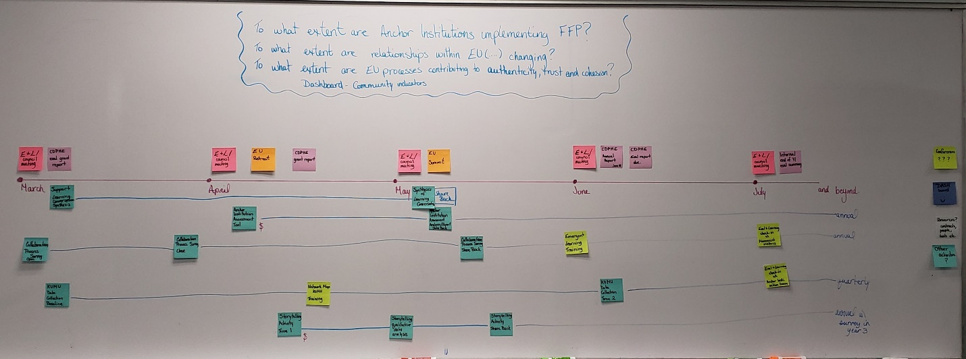
Summary:
Blue represents the evaluation activities we will engage in all are annual except for Kumu Map which has quarterly data collection based on the CDPHE evaluation report schedule. Activities include:
- Kumu Network Map
- Collaboration Survey
- Anchor Institution Assessment
- Storytelling (partnership activity)
Additionally, a member of the evaluation and learning team will intentionally support the Movement Makers during their Learning Conversation and Interpretation process between now and May)
Yellow represented Learning Activities and Training
- Kumu Network Map Training (March)
- Emergent Learning Training (June)
- Learning Activities with Action Teams (July)
Above the timeline are grant and EU related deliverables and meetings including CDPHE evaluation report, progress report, EU council Meeting and action team meetings.

- Next Steps
  - Sign up for Civic Network: https://www.civicnetwork.io/
  - Complete the Collaboration Process Survey: https://www.surveymonkey.com/r/euprocesssurvey
  - Caila will organize
    - Emergent Learning training
    - Kumu/Civic Network Training
    - Reach out to Lorenzo for the storytelling activity
  - Team members will keep their eyes out for capacity building opportunities they would like to participate in ex. Conferences, trainings, workshops etc.

- Trainings (optional):
  - Civic Network Webinar Training Series
    - Recorded Introduction: EU is the case study
    - Results and Outcomes:
    - KUMU Network Mapping:

  - Data Visualization
    - Visio Introduction: recording

  - Opportunity 360
A cross-sector data, community engagement and measurement tools
    - Recording: https://www.enterprisecommunity.org/resources/opportunity360-overview-and-qa-recording-8044

