Photo Banking Options

Pocket
- Operated by Mozilla Firefox
- Multimedia collection platform where links/images/anything on the web can be saved and tagged.
- https://getpocket.com/a/queue/
- Once saved to Pocket, the list of content is visible on any device — phone, tablet or computer.
- Can be viewed offline.
- Integrated into more than 1500 apps including Flipboard, Twitter and Zite.
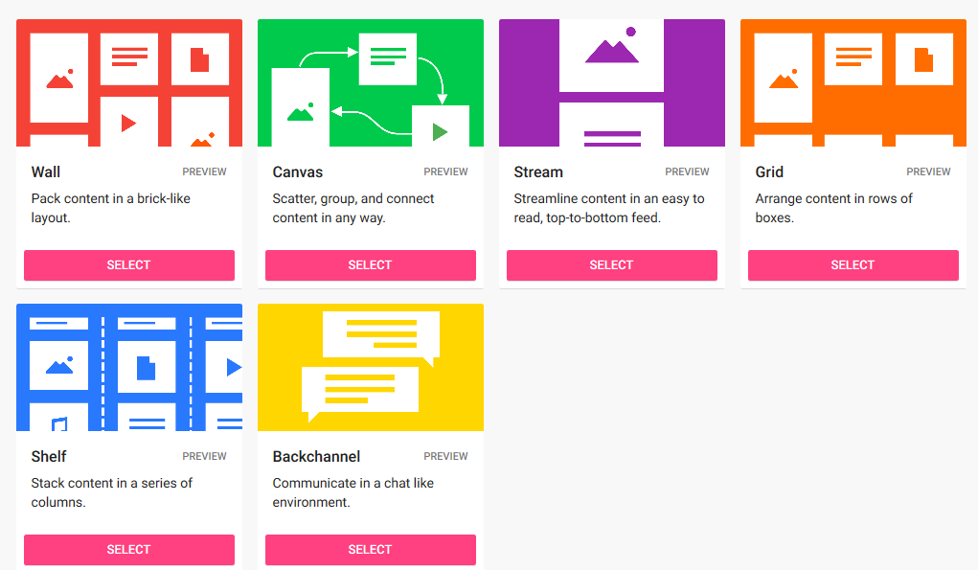
- It is available for major devices and platforms including iPad, iPhone, Android, Mac, Kindle Fire, Kobo, Google Chrome, Safari, Firefox, Opera and Windows.

Padlet
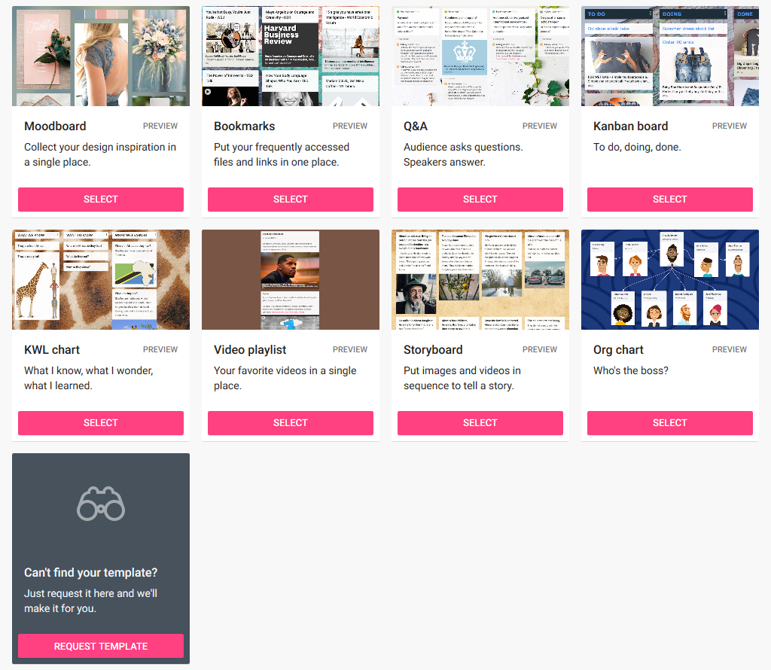
- Free version: 3 padlets, 10MB files only, ads.
- https://padlet.com/anna220/phl8b8ssn46e

Google Photos
- Shared grouping
- May exclude non-google users
- Create albums + etc
- Must have google account to access
- Core group of submitters?
- Could do google forms

Civic Network
- Shared
- Non-exclusionary for 365/google/doesn’t matter
- Simple upload format, no work/upkeep needed
- Simple list

The ECCP Website
- Core group of submitters/1 submitter
- “Post” different photos (anyone could theoretically contribute if their account permissions go through)
- Tags available
- Low set-up cost
- Opportunity for investment in building out the ECCP web platform
- Types
  - Google form
  - User submit plugin

