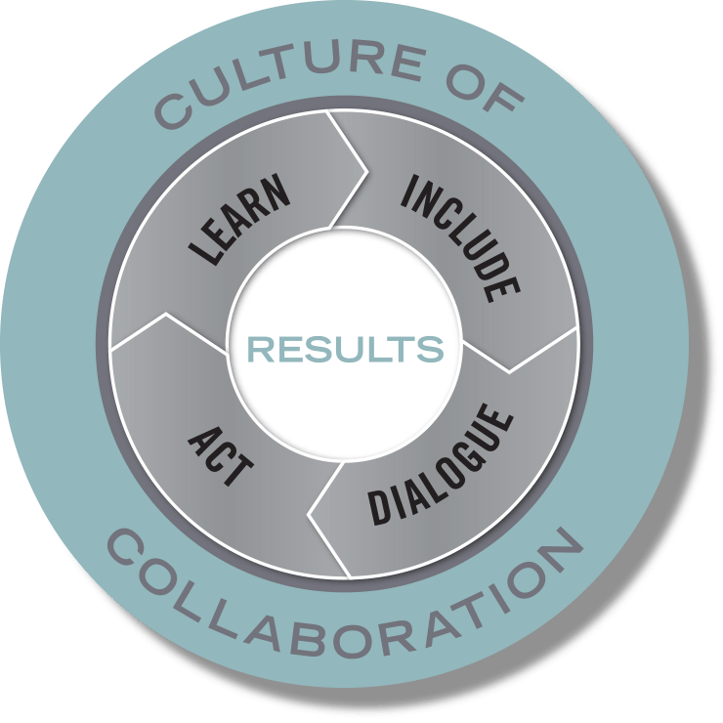
Action Planning Template

Team Name:

Members:

Team Lead(s):

Purpose:

Include – Ensure the various people, perspectives, and systems that need to be involved to achieve your results are engaged in the work.
- Who needs to be involved for this to be successful?
- Who will reach out to them?
- What needs to be in place for everyone to meaningfully participate?

Dialogue – Before jumping into action, take a minute to understand the context and the landscape, consider research and best practices, and tap into creativity and new possibilities.
- What do we know has been tried before, and what does research suggest is effective?
- What are the differing perspectives in the community on what we are trying to do, and how might we find common ground—or at least avoid conflicts?

Act – Create concrete plans that are clear on what actions will happen, who will do them, and when they happen. Plan just enough to get started, think in terms of the next 30-60-90 days.

Primary Strategy or Strategies:

What Will You Do? | Who Will Do It? | By When?

Learn – Set benchmarks and use performance measures to assess the impact and quality of actions; learn from experiences and translate that information into more effective actions.

How will we know if we are making progress toward achieving the results we seek? What will success look like in the short and long term? Consider questions like “How much? How well? And is anyone better off?”

Performance Measure | Target | Date

Culture of Collaboration – When and how will our team check in on our progress, learn from our experiences, and adapt our actions accordingly? Set a date to meet next, in person or by phone.

