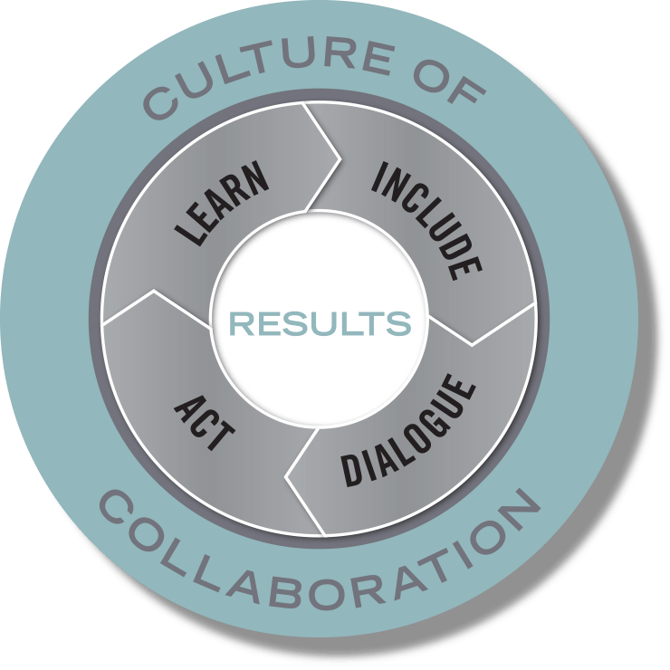
Action Planning Template

Team Name: SWFI Child Care Economics Action Team

Members: Matt Cornett, AD Works; Michelle Ewing, Arapahoe Cty Early Childhood Council; Merienisa Korban, SWFI student; Sharon Pendergast, ECPAC; Mary Russell, WLP; David Shapiro, EPIC; Victor Vialpando-Nunez, CCA; Janel Highfill, CCA

Team Lead(s): David Shapiro, EPIC; Victor Vialpando-Nunez, CCA; Janel Highfill, CCA

Purpose: The purpose of the SWFI Child Care Economics Action Team is to identify specific, actionable solutions to increase the affordability of quality care for parents while also ensuring the financial viability of care provision for center, home-based and informal care providers. Solutions to be explored for providers include: how to extend the benefits of child care tax breaks to broader array of care providers; expansion of public and private subsidies to underwrite business costs; new business models or structures to create more sustainable child care businesses that offer high quality care and livable wages for employees. Potential solutions for parents include: expansion of and/or re-prioritization of CCAP funds to address areas of most acute need; expansion of savings plan options and employer subsidies.

Include – Ensure the various people, perspectives, and systems that need to be involved to achieve your results are engaged in the work.
- Who needs to be involved for this to be successful?
- Who will reach out to them?
- What needs to be in place for everyone to meaningfully participate?

Successful providers in target markets under consideration

Dialogue – Before jumping into action, take a minute to understand the context and the landscape, consider research and best practices, and tap into creativity and new possibilities.
- What do we know has been tried before, and what does research suggest is effective?
- What are the differing perspectives in the community on what we are trying to do, and how might we find common ground—or at least avoid conflicts?

Successful corporate models – Goddard, Bright Horizons, etc. – include legal, HR, accounting supports for franchisees which provide critical, systems-oriented supports. Limitations of these models are their selectivity around locations and populations served.

Early Learning Ventures – provides shared services model, similar to the corporate support model, however, services as too expensive for many providers; their focus is on centers with 4-75 kids; ELV is one of several child care management systems available for child care owners/directors

Arapahoe County Early Childhood Council – Business Support Services, include business coaching, training, access to reduced cost legal and related services; focus on licensed providers

Key to child care business success: systems for all aspects of business operations, including expense tracking and other business details; directors and owners much know how to balance the business side with regulatory and parent demands/needs

Access to capital/funding is a challenge and a limitation: the cost of obtaining a Colorado Shines quality rating is unsurmountable for some providers; maintaining high quality standards requires ongoing funding; wage increases for staff can increase faster than providers ability to adjust tuition and/or parents ability to pay increased rates

Directors of large centers (over 75 kids) required to take 2, 3-credit courses for their director’s license: coursework includes administration and human relations; gap exists with owners who may have limited knowledge of child care regulations, requirements quality and strong business practices; pre-licensing training on regulations, business practices and how to balance could be beneficial

Classifications of child care providers:
- Child Care Centers - Can serve 1 child to as many as can legally fit in the building. Small, Private Owned child care centers tend to have between 4-75 children. Once you get past 75 children, the center can function better fiscally. This is considered the 'sweet spot'
- Family Child Care Home Providers - depends on license:
  - Family Child Care Homes - 6 children + 2 School Age (only one infant and one toddler allowed at a time)
  - 3 under 2 - allows the addition of an infant or toddler, still max of 6 children.
  - Experienced Provider - limit increases to 9 children
  - Large Home Providers - limit increases to 12 children and requires 2 teachers/providers
- Family, Friends, and Neighbors (Informal care providers) - Unlicensed care; cannot exceed more than 4 children of different families, can have as many direct family members as space allows.

Act – Create concrete plans that are clear on what actions will happen, who will do them, and when they happen. Plan just enough to get started, think in terms of the next 30-60-90 days.

Primary Strategy or Strategies:

What Will You Do? | Who Will Do It? | By When?
Pull existing revenue/cost models + start-up costs | Michelle | 4/2
Identify existing public/private dollars to support revenue model + potential new revenue sources | TBD
Collect info on care providers who have gone under: type, where, why | Sharon  Michelle | 4/2
Send info on which employers are investing in child care: how, where | David | 4/2
Build business mentoring model | TBD
Explore options to expand ELV and/or Arapahoe Cty business services models | TBD
Expand colleges (and others) ECE education offerings to include business education and support | TBD

Learn – Set benchmarks and use performance measures to assess the impact and quality of actions; learn from experiences and translate that information into more effective actions.

How will we know if we are making progress toward achieving the results we seek? What will success look like in the short and long term? Consider questions like “How much? How well? And is anyone better off?”

Child care facilities that have gone under – find out which type of facilities/providers, where, why

Revenue/cost model for child care – goal is to help investors and potential business owners understand start-up and ongoing costs for successful models

Employers investing in child care – which ones, how and where

Performance Measure | Target | Date
Identify/develop revenue and cost model for 3 types of care providers: 1) licensed home providers; 2) unlicensed informal care providers; 3) licensed centers with 4-75 kids |  | By June 11 meeting

Culture of Collaboration –
When and how will our team check in on our progress, learn from our experiences, and adapt our actions accordingly? Set a date to meet next, in person or by phone.

Revenue/cost models shared by: 4/2
Group reconvenes: 4/10 at 9:30 am

