Envision Chaffee County Action Team for Vision #1

Vision Statement: Our forests, waters and wildlife are healthy and maintained in balance with outdoor recreation.

Additional Water Quality Data for Chaffee County

**Overview:** The surface waters (Rivers, Streams, Lakes and Reservoirs) of Chaffee County are assessed here using information and data available from the Water Quality Control Division of the Colorado Department of Public Health and the Environment. The Arkansas River and many of its tributaries have been impacted by pollution from historic mining activities. It appears the water quality is improving, but there is continuing work to be done to identify sources of pollution and advocate for remediation.

**The Arkansas River:** The mainstem of the Arkansas River is the sixth longest river in the United States at approximately 1,460 miles. The river is spatially the largest river in Colorado, covering 27 percent of the state’s surface area. The river drops from the Continental Divide to 3,340 feet at the Colorado-Kansas state line, near the town of Holly. The Arkansas River valley widens and flattens markedly at Canon City as the Arkansas River enters the High Plains.

**Arkansas River Assessment Results:** For the Arkansas River Basin, 98 percent of the river miles and 71 percent of the lake acres have been assessed; 28 percent of the river miles and 27 percent of the lake acres are fully supporting all uses. An additional 0.75 percent of the river miles, and 0.42 percent of the lake acres, are supporting some of the classified uses.

**What Does Assessment Mean?**

The Water Quality Control Division monitors the quality of waters of the state. If the water quality meets all standards for the classified uses (Water Supply, Agriculture, Aquatic Life Use, etc.) then the water is Fully Supporting All Uses. In some cases, the water may support some uses, but not others. Some water bodies may not have adequate data to determine if the classified uses are met. When the water quality standards are not met, the water is classified as Impaired.

**Impaired waters of the State** are prepared once every two years and published as Regulation 93. Listings occur when a classified use is impaired. Listing types include:

* 4a. - TMDL – Waters are impaired and a Total Maximum Daily Load (TMDL) has been prepared that identifies sources of the contamination and limits the amount from the various sources.
* 5. - 303(d) – Waters are impaired and a TMDL is to be prepared. Priority High (H) means that this process is to be scheduled as Colorado Water Quality Control Division resources are available.
* 3b. - M&E list – impairment is uncertain, the Monitoring and Evaluation (M&E) list designates the segment will continue to be monitored.

**A TMDL establishes the maximum amount of a pollutant allowed from various sources in a water body. It serves as a starting point or planning tool for restoring water quality.**

**The Status of the Arkansas River compared to other River Basins in Colorado:** Statewide only 58.2% meet all or some standards. The Arkansas River Basin meets all or some standards only 29% of the time.

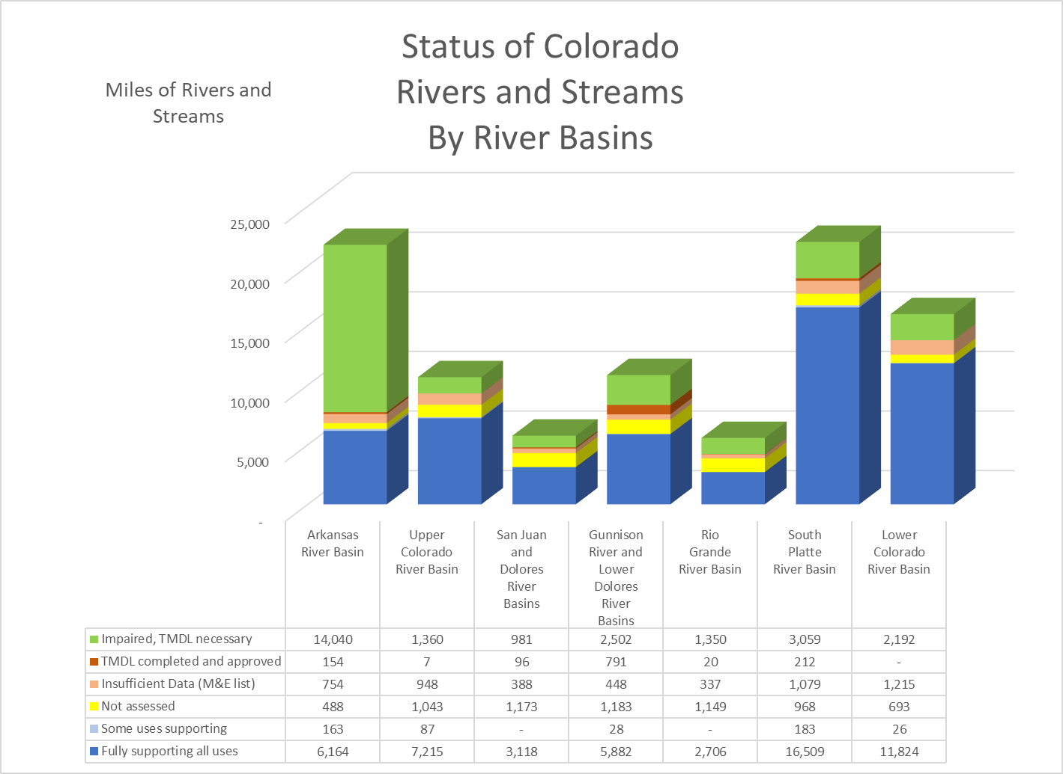

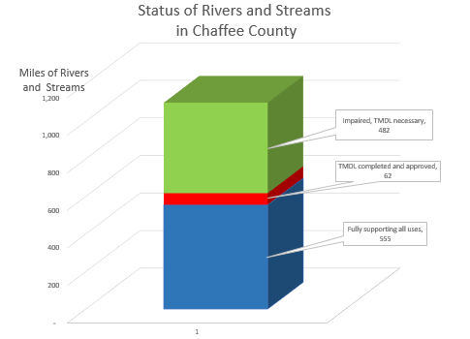**Chaffee County Rivers and Streams Assessment Results:** The status of the Rivers and Streams of Chaffee County meet use classification standards far more than the Arkansas River as a whole. In Chaffee County 50.4% of rivers and streams meet classified use standards. The other half of Rivers and Streams in Chaffee County either have or need a TMDL.

Note: some of the waters classified as impaired in Chaffee County are in Lake County but the segments are included in both counties when the segment crosses the county lines.

*Information on Lakes and Reservoirs is at the end of the report.*

**Impaired Rivers and Streams in Chaffee County**

The following sections list the impaired rivers and streams in Chaffee County with some historical water quality data for the county extracted from the State’s water quality portal at the following website: <https://www.waterqualitydata.us/portal/>. This website includes data collected by the USGS and data stored in STORET (data collected by the CDPHE Water Quality Control Division (WQCD), EPA and other third parties).

Most monitoring sites in Chaffee County have records of water quality for some periods of time and then gaps between continued monitoring. The charts presented are for selected specified periods of time when there was relatively continuous monitoring.

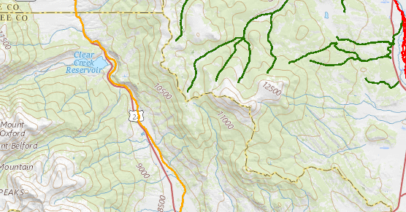**The mainstem of the Arkansas**

The mainstem of the Arkansas River from just above the Lake County / Chaffee County line to the Chaffee County / Freemont County line is shown on the maps in orange.

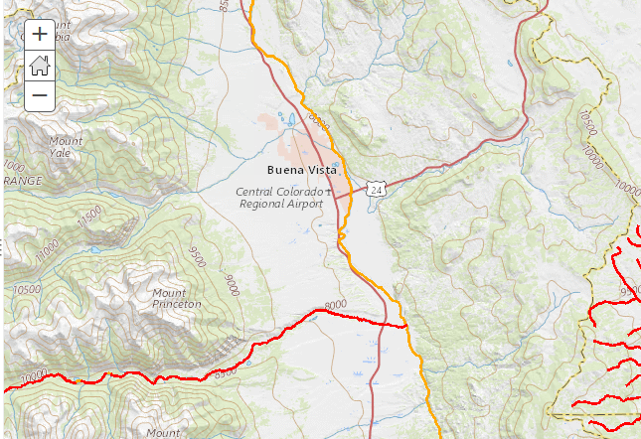

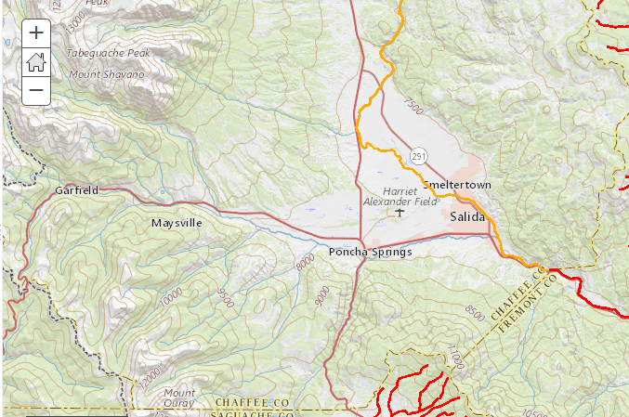

From the 2018 303(d) List of Impaired Waters:

Listed portion: **COARUA03_A**  Mainstem of the Arkansas River from a point immediately above the confluence with the Lake Creek to the Chaffee/Fremont County line.

Affected Use Analyte Category List Priority

Aquatic Life Use Cadmium (Dissolved) 4a. - TMDL NA

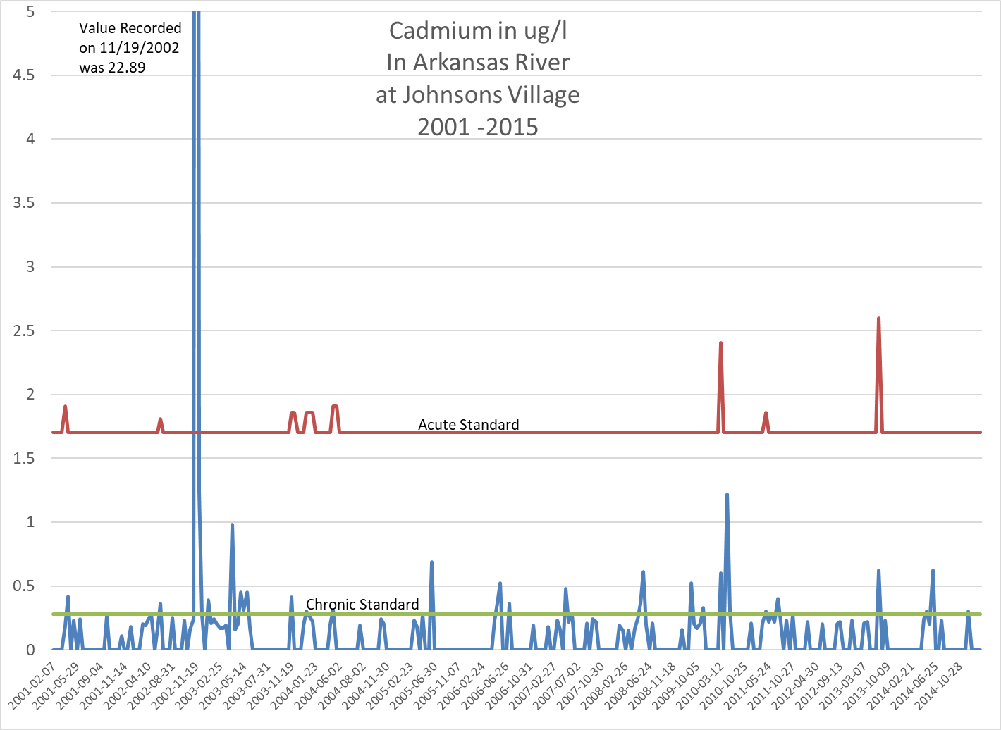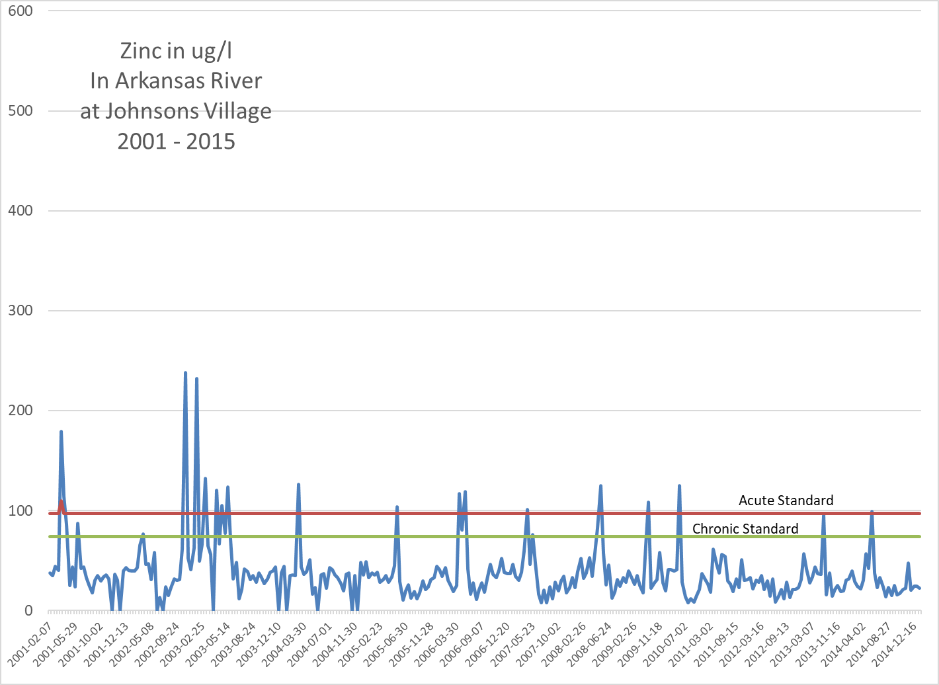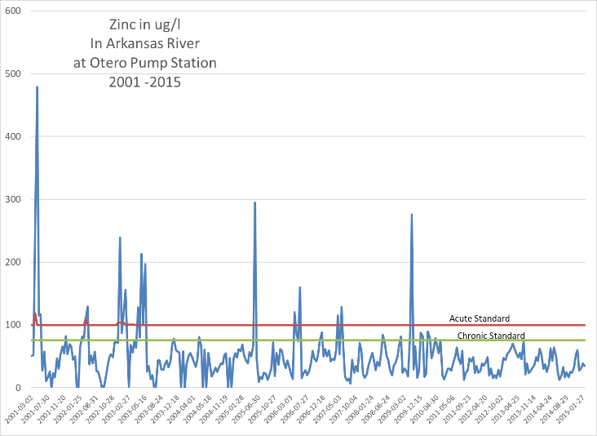Aquatic Life Use Zinc (Dissolved) 4a. - TMDL NA

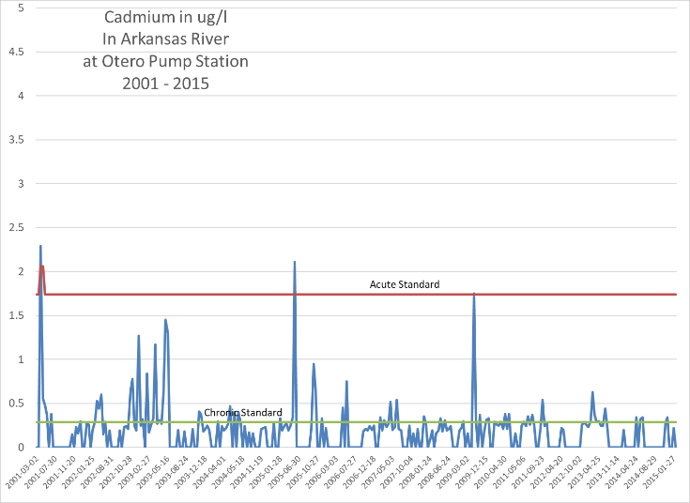

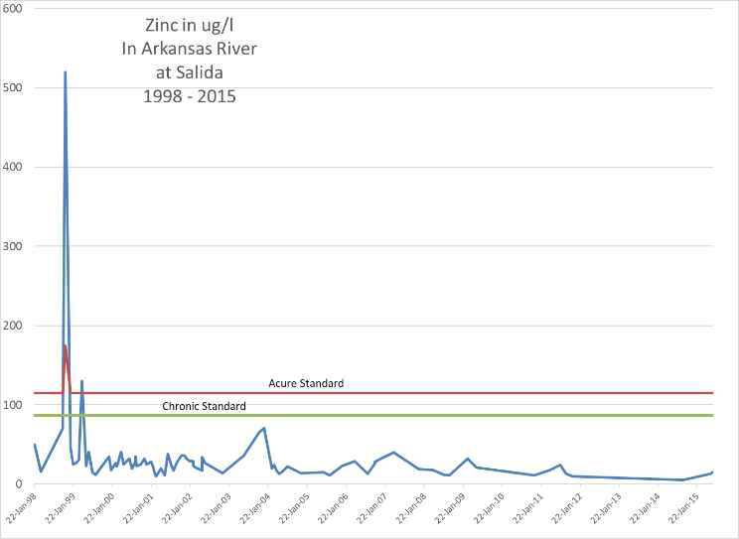The data collected at these sites cannot always be matched in a specific period of time. For instance, the spike in zinc concentrations in 2001 at Otero Pump Station occurred in days that no measurement was recorded at Johnsons Village.

Overall, it appears that there are additional Cadmium (and probably other metals) contributions to the Arkansas from tributaries below the Otero Pump Station and above Johnsons Village. The Zinc concentrations seem to be reduced by the time the river reaches Salida.

**Tributaries to the Arkansas above Browns Creek:**

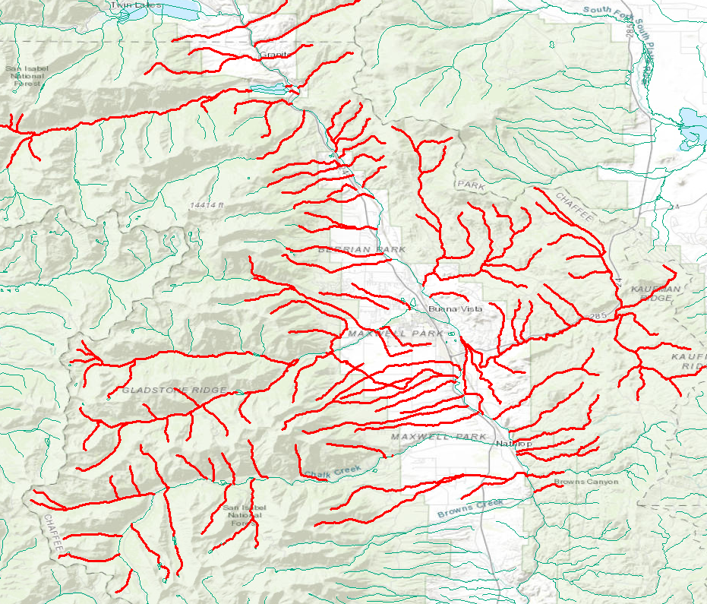All Tributaries of the Arkansas River from above the Lake – Chaffee County line to the confluence with Browns Creek is listed as impaired for Zinc and Copper. There are only a few current monitoring stations along these tributaries. In the charts above comparisons of Zinc and Cadmium concentrations can be made for various points along the Arkansas, where there has been monitoring.

From the 2018 303(d) List of Impaired Waters:

Listed portion: **COARUA05_A** All tributaries to the Arkansas River, including wetlands, from the source to immediately below the confluence with Brown's Creek, except for specific listings in segments 6 through 12b. Except Lake Fork below Sugarloaf Dam.

Affected Use Analyte Category List Priority

Aquatic Life Use Copper (Dissolved) 5. - 303(d) H

Aquatic Life Use Zinc (Dissolved) 5. - 303(d) H

The Charts below show Copper monitoring at various locations along the Arkansas River for different periods of time.

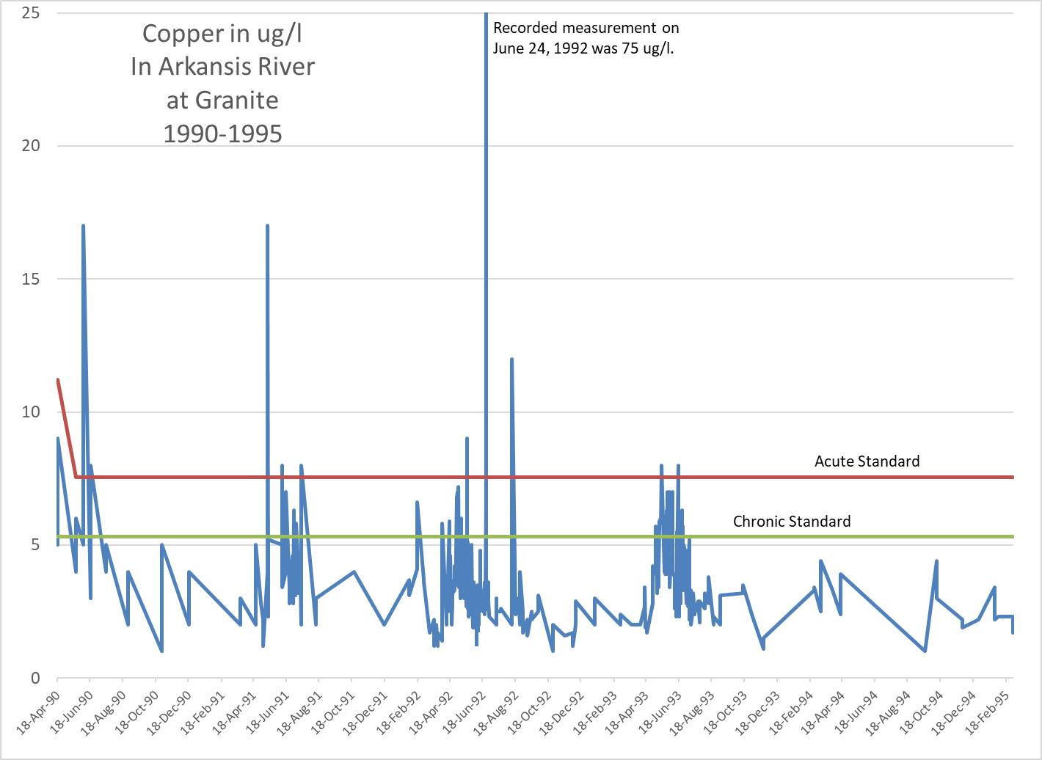

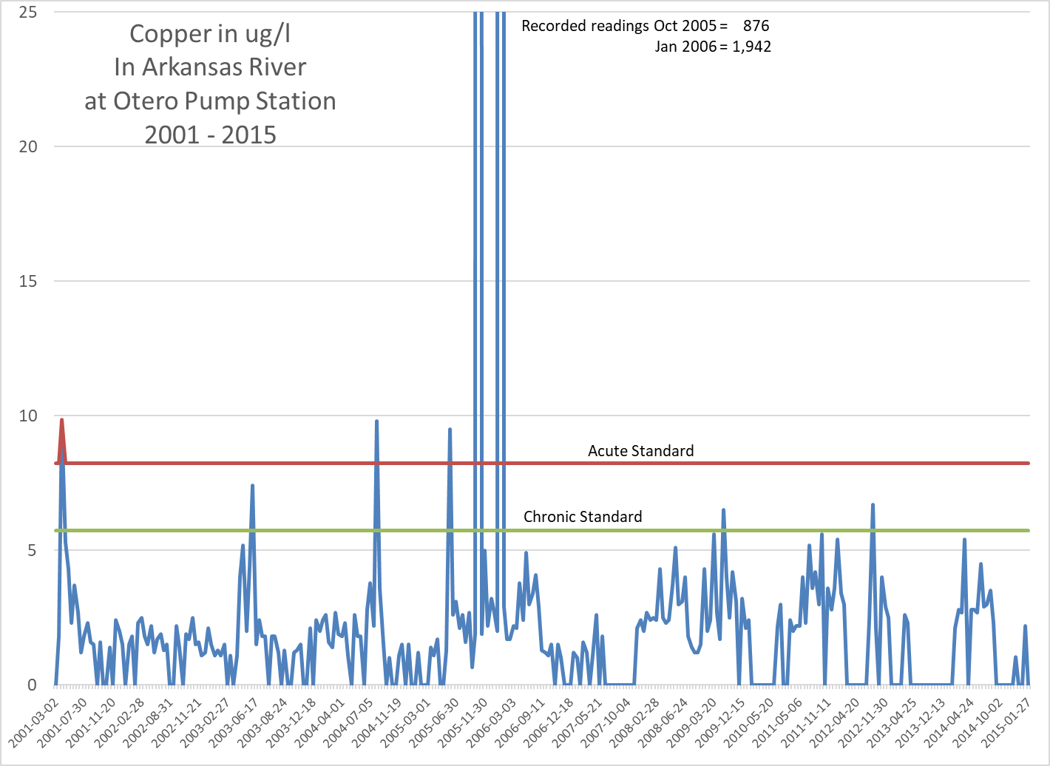

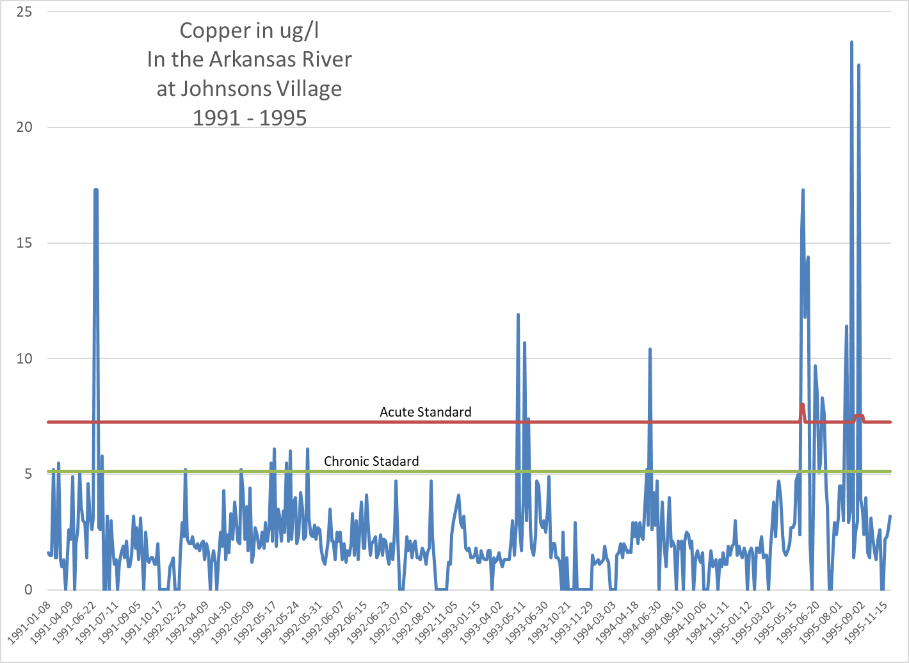

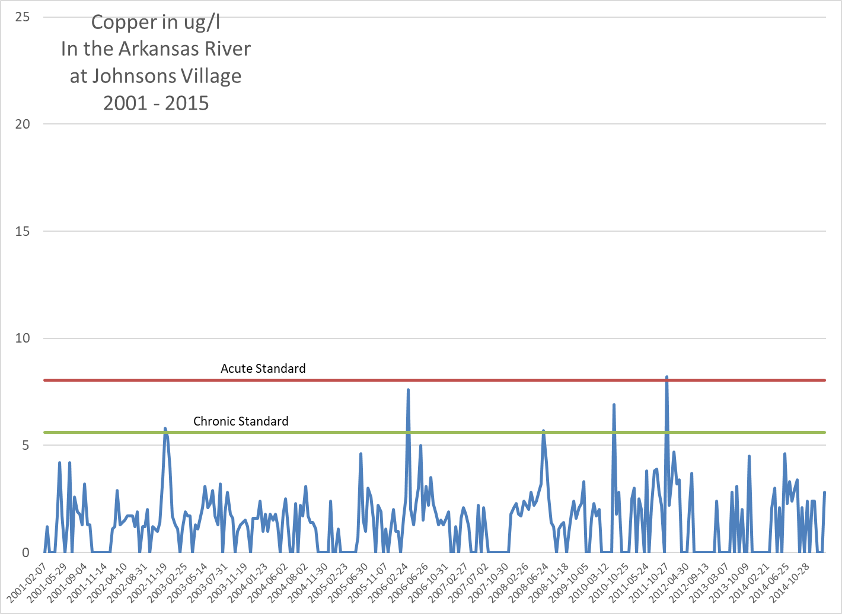Conclusion: Based on the graphs above, it appears the water quality of the Arkansas River has improved from the quality of the 1990s when there was significant metal loading from historic mining in the Leadville area. The Superfund clean-up in Leadville seems to have made a dramatic improvement on the water quality. However, there appears to be some loading from tributaries between Lake Creek and the confluence with Browns Creek. Since these tributaries are listed on the 303(d) list with high priority, when Water Quality Control Division funding is available, there will be more monitoring and evaluation of sources to prepare the Total Maximum Daily Load (TMDL) for these tributaries. As sources are identified remediation plans may follow.

**Chalk Creek**

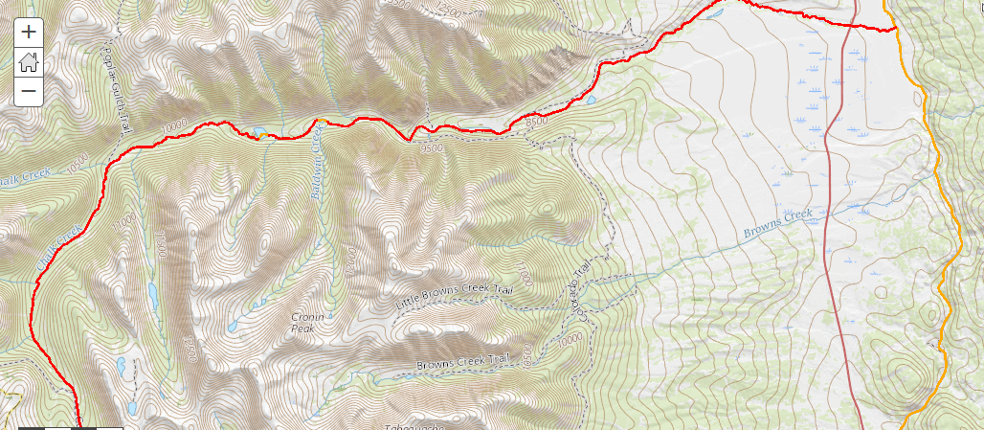

From the 2018 303(d) List of Impaired Waters:

Listed portion: **COARUA12a_A** Mainstem of Chalk Creek from the source to the confluence with the Arkansas River.

Affected Use Analyte Category List Priority

Water Supply Use Arsenic (Total) 3b. - M&E list NA

Aquatic Life Use Lead (Dissolved) 4a. - TMDL NA

Aquatic Life Use Zinc (Dissolved) 4a. - TMDL NA

Aquatic Life Use pH 4a. - TMDL NA

Aquatic Life Use Aluminum (Dissolved) 4a. – TMDL NA

Aquatic Life Use Cadmium (Dissolved) 5. - 303(d) H

A great deal of water quality sampling was done at various locations in Chalk Creek during the 1980s and early 1990s. This was most likely an effort to find the sources of the metal loading in Chalk Creek and resulted in establishing the Total Maximum Daily Loads (TMDLs) listed above.

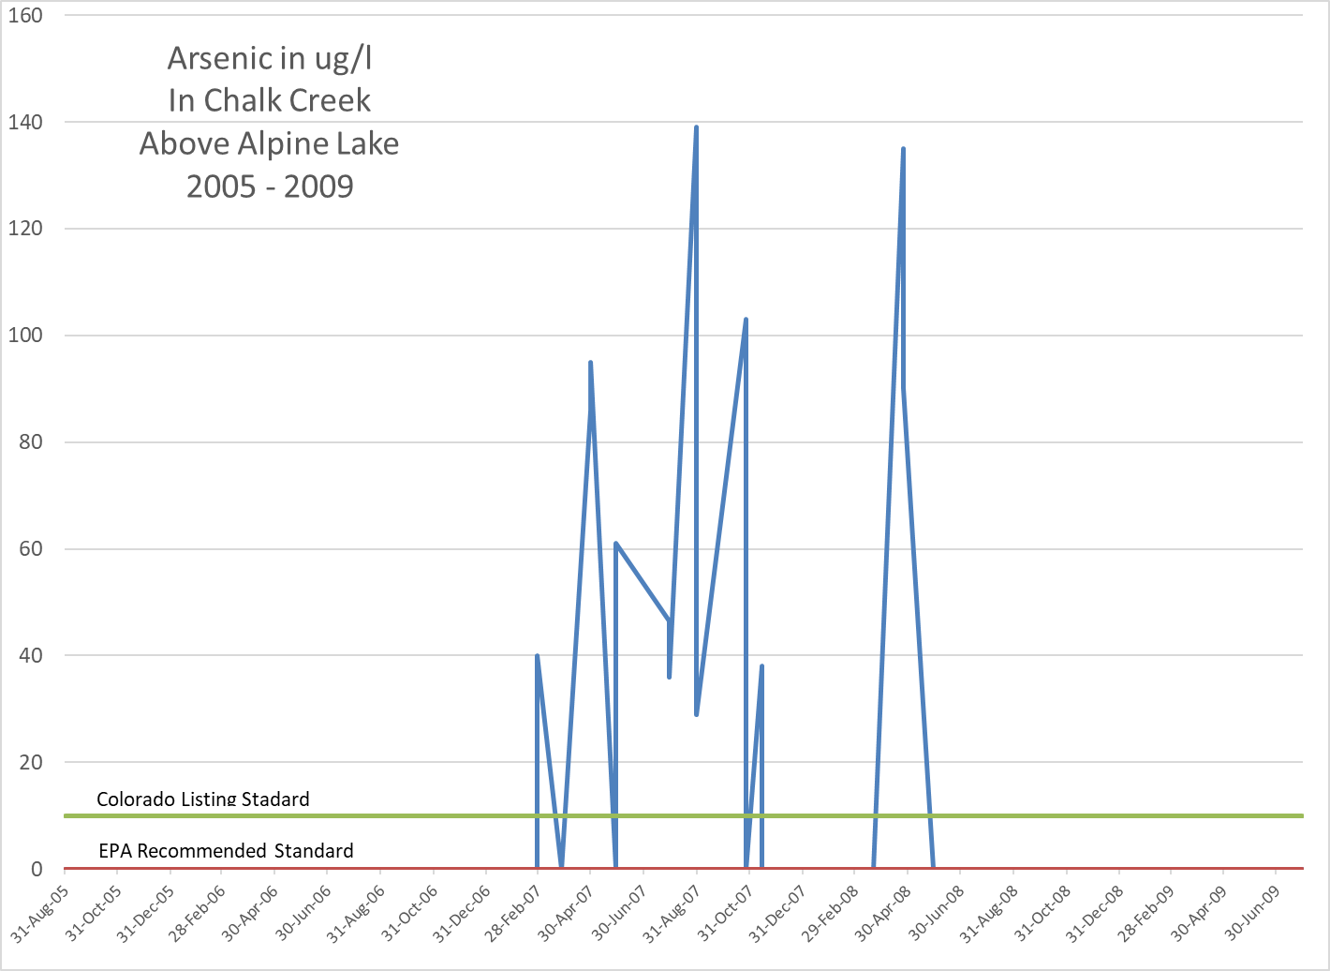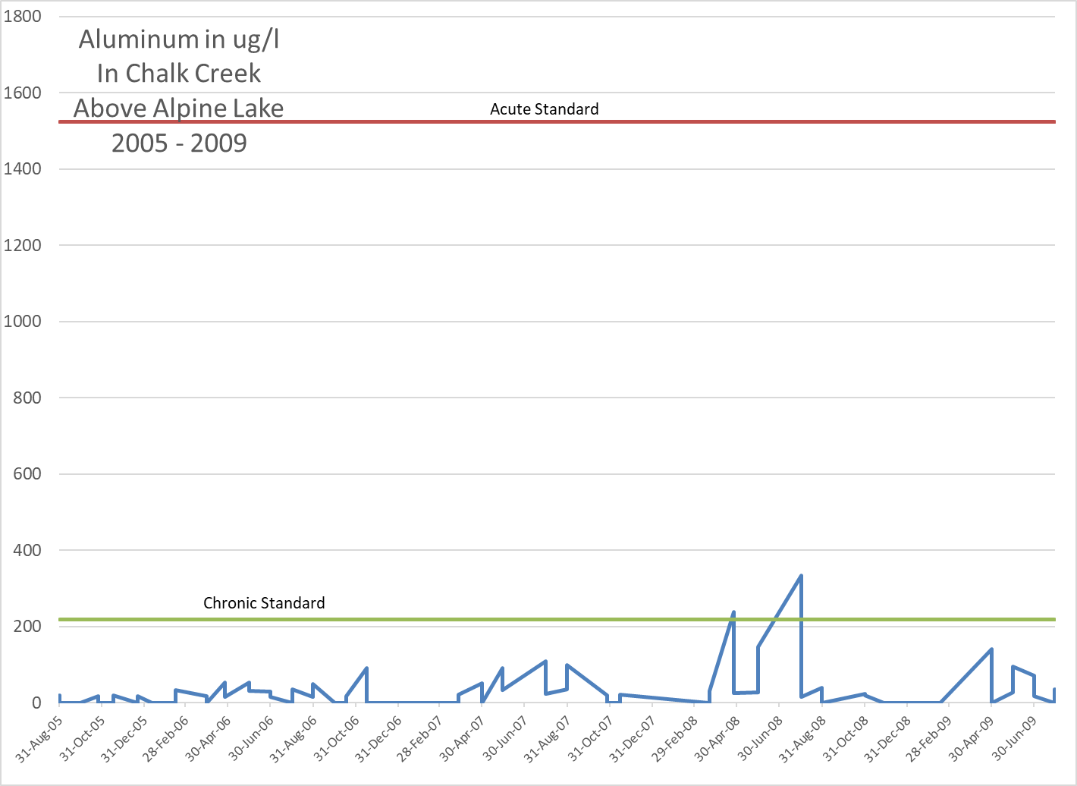The only monitoring site that seems to have consistent data collection is above Alpine Lake.

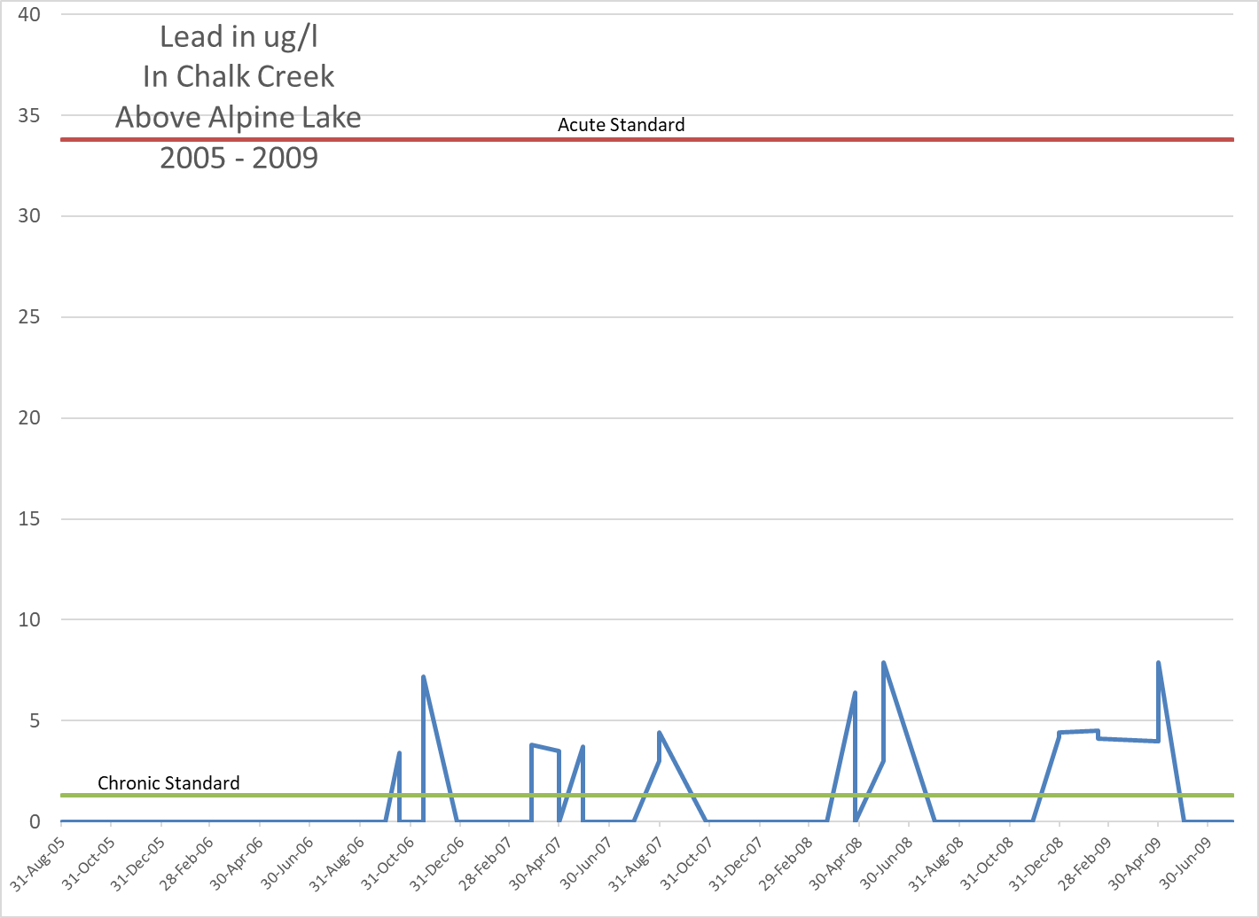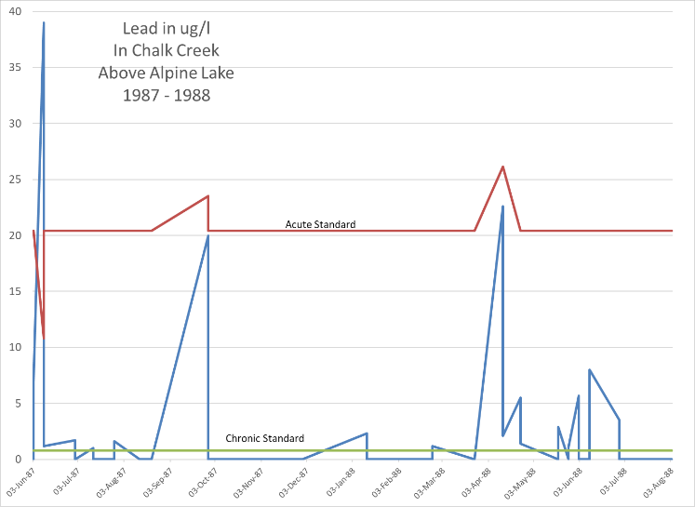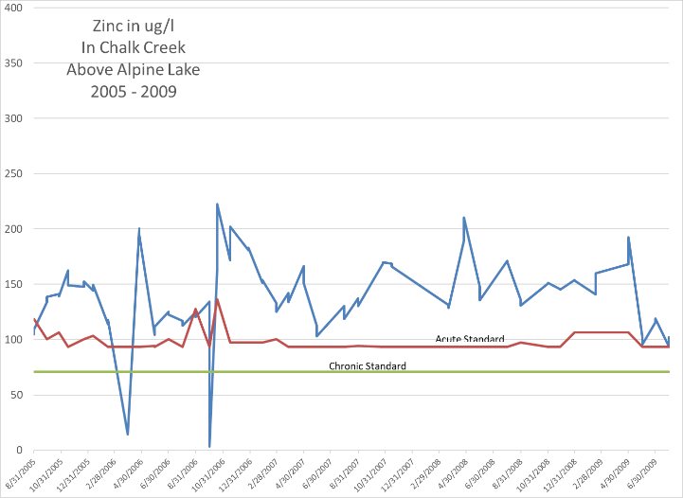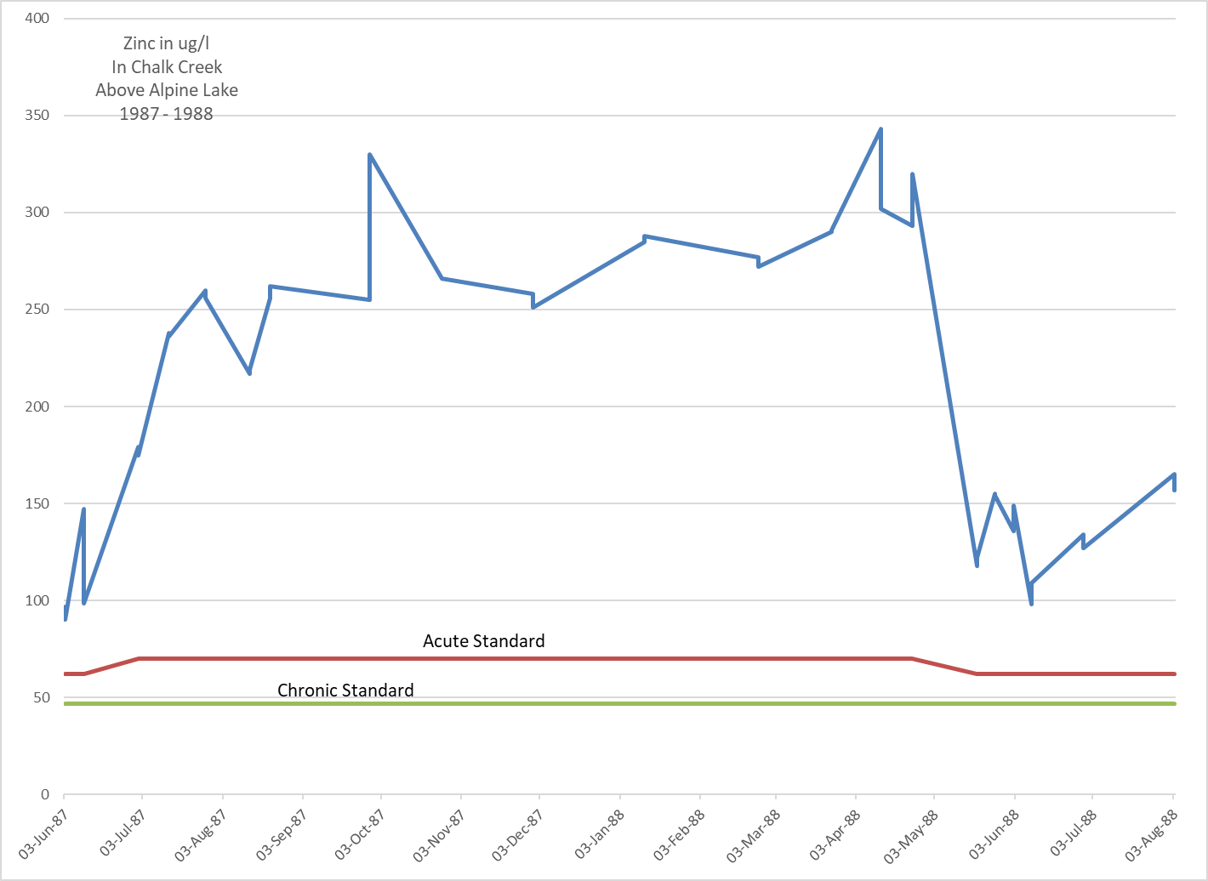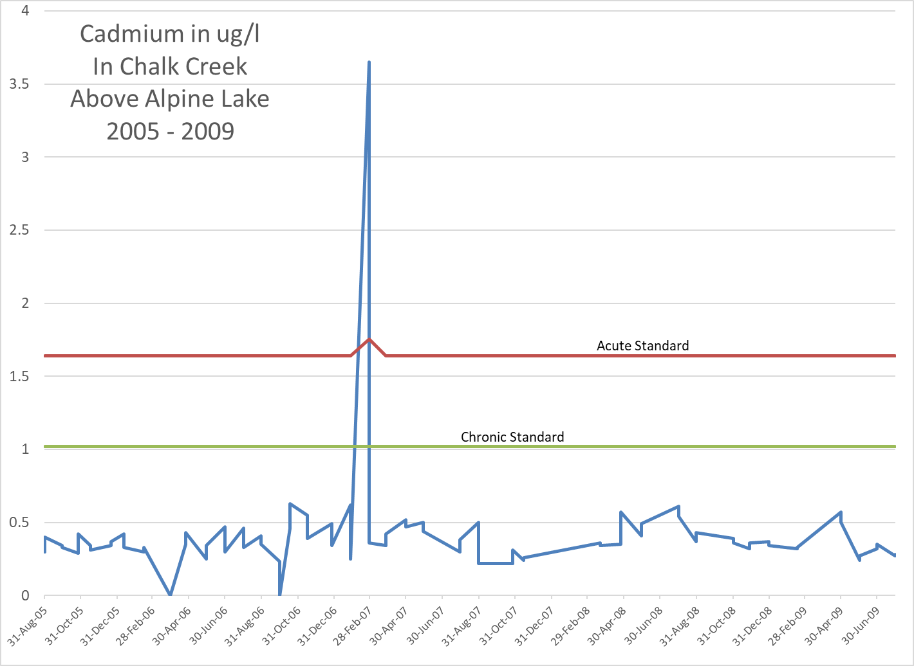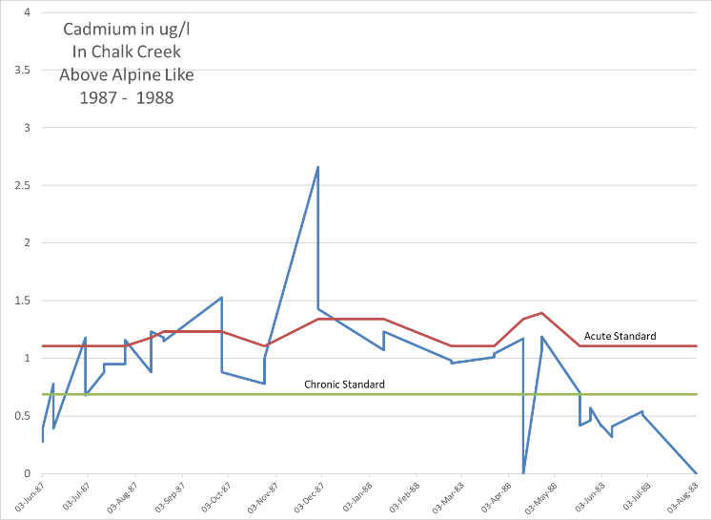

Conclusion: There is still loading of various pollutants in Chalk Creek. It appears that the amount of contamination has been diminished from the historical levels. Hopefully, the flair-up of Arsenic that occurred from the Spring of 2007 to Spring of 2008 was a one-time event and will not recur. A spike of Cadmium occurred in November of 1987 but has been more controlled since. There are TMDLs in place for lead, zinc, aluminum and pH. A TMDL will be developed for Cadmium, as WQCD resources are available. With Arsenic being on the Monitor and Evaluation (M & E) list monitoring should continue to occur.

Tributaries to Lake Creek:

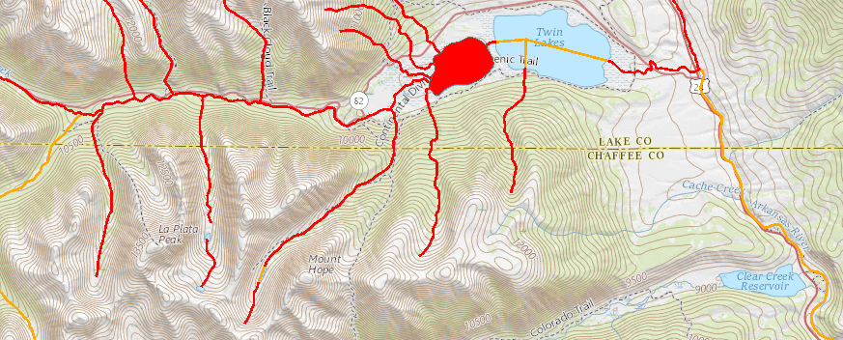

From the 2018 303(d) List of Impaired Waters:

Listed portion: **COARUA10_A** Mainstem of Lake Creek, including all tributaries and wetlands, from the source to the confluence with the Arkansas River, except for the specific listing in segment 11.

Affected Use Analyte Category List Priority

Aquatic Life Use Copper (Dissolved) 4a. - TMDL NA

Aquatic Life Use Dissolved Oxygen 5. - 303(d) H

Aquatic Life Use pH 5. - 303(d) H

There are a number of tributaries of Lake Creek that originate in Chaffee County in the La Plata Peak, Mount Hope area. These tributaries are listed as impaired and are included in the Chaffee County impaired statistics even though the majority of the Lake Creek tributaries are in Lake County. There are no monitoring stations listed in Chaffee County for these creeks.

**Lakes and Reservoirs of the State:** On a statewide basis 39.4% of the Lakes and Reservoirs do not have a current assessment. Only 30.3% of the Lakes and Reservoirs acreage fully supports all classified uses. In the Arkansas River Basin 28.5% of the Lake and Reservoirs acreage do not have a current assessment and only 27.1% fully support all classified uses.

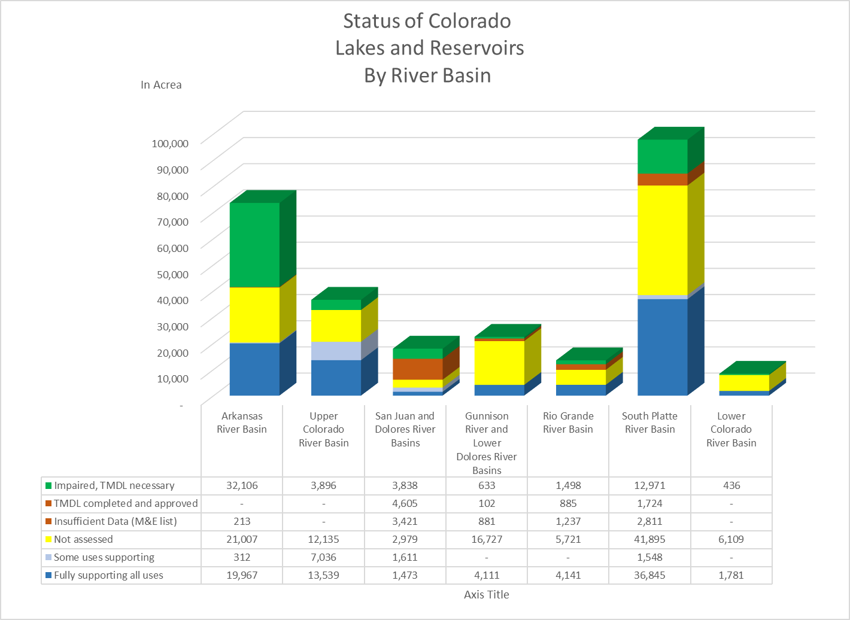

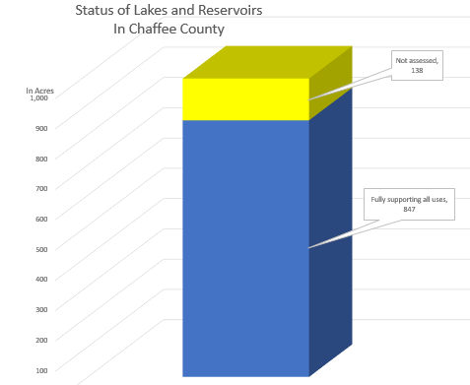**Chaffee County Assessment of Lakes and Reservoirs:** All the Lakes and Reservoirs in Chaffee County, which have been assessed, fully support all classified use standards. Only 14% of lake and reservoir surface area have not been assessed.

Therefore, the stored waters in Chaffee County’s lake and reservoirs are high quality.

**Sources:**

Maps: CDPHE-Water Quality Control Division – Stream Impairment Maps - <http://cdphe.maps.arcgis.com/home/webmap/viewer.html>

Google Earth with a layer provided by Water Quality Control Division containing all monitoring stations in Chaffee County. ChafeeCounty– WQStations.kmz

Water Quality Data: Water Quality Control Division water quality portal <https://www.waterqualitydata.us/portal/>

Impaired Waters of the State of Colorado: Integrated Water Quality Monitoring and Assessment Report 2018 – Water Quality Control Division.

Impaired Segments – [Regulation 93](https://www.colorado.gov/pacific/sites/default/files/93_2016%2811%29.pdf): Colorado's Section 303(d) List of Impaired Waters and Monitoring and Evaluation List for 2018.