Action Planning Template

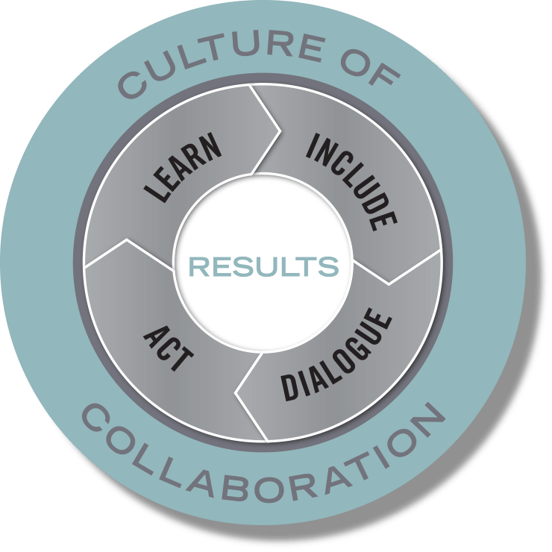
Team Name: Public Policy Action Group

Members: Rich Jones, Bell Policy Center; Bob Provost, Arapahoe County; Renice Walker, Colorado Workforce Development Council and CDE; Lisa Jansen Thompson, Early Childhood Partnership of Adams County; Alison Friedman Phillips, Women’s Foundation of Colorado; Jessica Cassarino, Community College of Aurora; Tracey Stewart, Gary Community Investments

Team Lead(s): Rich Jones

Purpose: The Public Policy Action Group will review current public policies governing child care and early childhood education services and identify those that create barriers for expanding families’ access to these services. We will also develop public policy proposals to expand access to affordable child care and early childhood education services for more Colorado families.

Performance Measures:
- Identify the barriers to affordable and accessible child care that currently exist because of public policy.
- Develop a list of current policy initiatives being considered and develop an understanding of what they do and how they affect our goals.
- Develop a framework for considering and developing policy.
- Identify how public policies interact with each other.
- Identify areas to pilot changes to help address the barriers – maybe waivers from current rules.

Include – Ensure the various people, perspectives, and systems that need to be involved to achieve your results are engaged in the work.
- Who needs to be involved for this to be successful?
- Who will reach out to them?
- What needs to be in place for everyone to meaningfully participate?
Colorado Department of Human Services staff – those working on CCCAP and CO Works - Rich
Colorado Center for Law and Policy - Rich
Colorado Children’s Campaign - Rich
Early Childhood Leadership Commission - Lisa
Gary Community Investment - Alison
Denver Human Services staff that work on CCCAP - Lisa
Aspen Ascend Program – contact Colorado fellows - Bob
CCCAP providers – Possibly one from Adams County that is active with their CCCAP program - Lisa
Denver Preschool Program – Jennifer Landrum – Lisa (?)

We should ask them to be content experts for us if they cannot commit to fully participating in the Action Group.

Dialogue – Before jumping into action, take a minute to understand the context and the landscape, consider research and best practices, and tap into creativity and new possibilities.
- What do we know has been tried before, and what does research suggest is effective?
- What are the differing perspectives in the community on what we are trying to do, and how might we find common ground—or at least avoid conflicts?

Background on HB14-1317 – CCCAP Reform Bill
Background on 2018 JBC proposal to restructure CCCAP
Background on the Tulsa CAP program that links workforce training for parents with high quality child care for their children.
Scan of existing policies and policy proposals in this area – maybe something CCLP has done?
Background on the Enterprise Zone Tax Credit and if it can be used to attract child care providers to underserved areas and child care deserts.

Act – Create concrete plans that are clear on what actions will happen, who will do them, and when they happen. Plan just enough to get started, think in terms of the next 30-60-90 days.

Primary Strategy or Strategies:
We will start to gather and assess background information on the current and proposed policies in this area.

What Will You Do? | Who Will Do It? | By When?
Invite people to describe current proposals and provide background on them to the group. Share background information that is described in the “Dialogue” section | Rich and others listed in Include section | 30 days
Share notes and detailed suggestions from the January Learning Community Meeting | Jessica | 30 days
Invite the staff from CDHS to the group to explain how state and federal rules limit what we can do. Louis Garcia, a financial staffer at CDHS, would be a good person to invite | Bob | 30 days

Learn – Set benchmarks and use performance measures to assess the impact and quality of actions; learn from experiences and translate that information into more effective actions.

How will we know if we are making progress toward achieving the results we seek? What will success look like in the short and long term? Consider questions like “How much? How well? And is anyone better off?”

Performance Measure | Target | Date
We need to make sure all members have materials in advance with an established date to complete our preparation. That way we can be prepared for full discussions in the meetings.
We will need to decide on how to (1) assess the various policy proposals and (2) come to agreement when there might be conflicting viewpoints.

Culture of Collaboration – When and how will our team check in on our progress, learn from our experiences, and adapt our actions accordingly? Set a date to meet next, in person or by phone.

