ECONOMIC & ENVIRONMENTAL IMPACTS OF
A GEOTHERMAL ELECTRICITY
GENERATION FACILITY NEAR
BUENA VISTA, COLORADO

Mt. Princeton Geothermal, LLC
January 2018

ECONOMIC & ENVIRONMENTAL IMPACTS OF A GEOTHERMAL ELECTRICITY GENERATION FACILITY NEAR BUENA VISTA, COLORADO

Introduction and Statement of Purpose

This report presents estimates of the economic and environmental impacts of a proposed 10 megawatt geothermal electricity generation facility southwest of Buena Vista, Colorado, which is located in south central Colorado in Chaffee County. A plant this size would fulfill the 3-county service area of Sangre De Cristo REA. This would be the first geothermal power plant in Colorado, following similarly successful operations in New Mexico, Nevada, Utah, California and Idaho.

To estimate the economic impacts of the proposed project during all phases of development from prospecting to construction and operation, an input-output model of the Chaffee County economy was built using an economic base modeling approach based on the JEDI econometric model developed by the National Renewable Energy Laboratory located in Golden, Colorado.

To estimate the annual environmental impacts of the proposed project based on avoided greenhouse gases, calculations have been made comparing the generation of 10 MW geothermal power plant, compared to the same amount of electricity provided by coal-powered generation.

Geothermal Electricity Generation

Historically, reservoirs containing geothermal water at temperatures of 175°F to 350°F were considered too cool for use in electricity generation. With the onset of binary power technologies, this is no longer true. Through the employment of a heat exchanger, geothermal water can be used to heat a second (binary) fluid in a separate, adjacent pipe loop. The second fluid, usually isobutane or isopentane (commonly used in air-conditioning systems), boils and flashes at a lower temperature than water. The vapor from the working fluid (binary), like the steam in a flash plant, powers the turbine generator, producing electricity. Binary power plants are usually more expensive, but allow for utilization of moderate-temperature geothermal resources and are more environmentally-friendly because they are closed systems, resulting in less heat loss and no release of water.

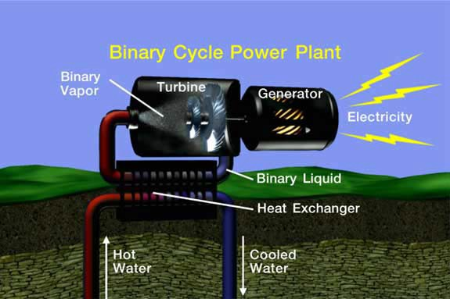

Source: Geothermal Education Office

- The Mt. Princeton Geothermal Energy Project

During the 1970’s the region surrounding the Mt. Princeton project site was identified by oil companies as a potential geographic location for geothermal steam resources. Based on that information, as well as preliminary exploration conducted by the Colorado School of Mines, Boise State University, the Colorado Geological Survey, the Imperial College of London and Mt. Princeton Geothermal all indicate a significant geothermal resource. Mt. Princeton Geothermal, LLC., has identified a possible reservoir, but its extent, volume, and thermal properties are not known at this time. Fortunately, this is a hydrothermal reservoir, and will not require any fracking in order to develop.

Technologies vary depending on the nature of the resource; therefore, significant site analysis is still necessary, including test drilling, to evaluate the resource and determine whether it is suitable for electricity generation and the appropriate technology to be applied. Test drilling can cost up to $1 million per well and “hitting” the geothermal reservoir on the first test well is not guaranteed.

The uncertainty of the resource combined with the significant financial and regulatory requirements make it difficult to specify a timeline for the period between final site identification and completion of plant construction. Three years from the beginning of prospecting to completion of construction would be possible under the best circumstances. However, the time required for raising venture capital, completing the permitting process, negotiating land leasing arrangements, assessing the geothermal resource, sourcing the technology, and planning construction could easily stretch the timeline to 10 years, depending on individual project characteristics.

Economic impacts from operation of the proposed geothermal electricity generating facility are expected to be long-term. Electricity generated by geothermal resources is classified as “renewable” by the U.S. Department of Energy. In terms of long-term operations, geothermal wells for electricity generating plants have life spans that vary from several decades to centuries, depending on the geothermal resource, the rate of resource renewal, the effectiveness of reinjection, and the rate of extraction. The phrase “long-term” is used in reference to the operation of the proposed geothermal plant at Mt. Princeton to reflect that the plant will continue to produce electricity in perpetuity. Estimated impacts will be reported on an annual basis with the expectation that they will continue to accrue for as long as the facility operates.

- Clean Energy Employment and Rural America

Rural communities in general face many unique challenges. Lack of stable, secure, long-term jobs in rural communities leads many young adults with the most education and the greatest earning potential to emigrate, leaving a poorer, older, and smaller population. They tend to focus on a single source of revenue, such as tourism or agriculture, and this can contribute to unemployment and economic instability. Since mining has been inactive for several decades now, Chaffee County has evolved to capitalize on natural beauty and recreational opportunities. With a long history of
summer homes, the peak population occurs during the height of summer when second homeowners occupy their mountain homes. These residents contribute much needed revenue to the summertime economy.

While the current economic base will continue to play an important role in the future, residents see the need to diversify and build a more robust and sustainable economy. Geothermal resources represent opportunities for sustainable natural
resource development that fits the community as it has evolved. Renewable energy projects offer an important means of diversifying the economic base and simultaneously adopting an innovative income-generating strategy to build on clean energy assets, diversify economies, and attract new businesses. Such diversification is a direct indicator of economic stability. The jobs within the clean energy sector cover a broad spectrum of skills, and draw from a diverse selection of applicants.

- Types of Jobs Created

Geothermal provides long-term income for people with a diversity of job skills. People
employed by the sector include welders; mechanics; pipe fitters; plumbers; machinists; electricians; carpenters; construction and drilling equipment operators and excavators; surveyors; architects and designers; geologists; hydrologists; electrical, mechanical, and structural engineers; HVAC technicians; food processing specialists; aquaculture and horticulture specialists; managers; attorneys; regulatory and environmental consultants; accountants; computer techs; resort managers; spa developers; researchers; and government employees. Construction employment for installing access roads, pipelines, transmission lines, drill sites, and power plants will likely occur, though the amount would vary depending on the resource potential. The type of employment and number of available jobs would also vary as the construction proceeds.

The Economic Impacts of the Mt. Princeton Geothermal Project

Economic impacts of the Mt. Princeton Geothermal project include the direct, indirect, and induced effects of economic activity. Thus, these impacts include the direct impacts of project related expenditures and the backward linkages of that spending as it circulates throughout the economy, i.e. the multiplier effects. It also includes the impacts of consumer spending relating to this economic activity.

The development of the geothermal resource located near Buena Vista for the purposes of electricity generation would have significant and lasting impacts on the local Chaffee County Economic Region. It is expected that 85 percent of the impacts from operation will accrue to local communities in the Buena Vista-Salida region. Of the 228 jobs created, approximately 150 new jobs would be in the same region. An estimated additional $10.2 million in local spending during construction and $900,000 thereafter annually for maintenance and operations is also expected to accrue to the region. In addition, the increased property tax revenues of about $550,000 annually can be expected to accrue to the county which can be used to reduce the property tax burden of existing constituents and to support new community projects. In the rural areas of Colorado, the benefits which will accrue to the Buena Vista and Salida communities could be very important to the future well-being of local residents.

- Geothermal Power Plants and Tourism

Most geothermal power plants will either not affect tourism or cause it to increase. Take the example of the power plant at Mammoth Lakes, California, a sight of heavy outdoor recreation and active fisheries. Although people initially opposed the project due to worries over tourism impacts, the project is now highly regarded among community members and visitors alike. Many people in the city do not even know the power plant exists because it was so expertly engineered to blend into the surrounding environment.

Tourism might increase when students, scientists, or interested individuals visit the site of the power plant, thereby bringing business to the local community, but rarely does geothermal development negatively impact tourism. It’s conceivable that the Colorado School of Mines might locate a Geothermal Academy in Chaffee County, which would promote the advancement and widespread adoption of geothermal technologies through academic research, educational programs and dissemination of local project information and analytics.

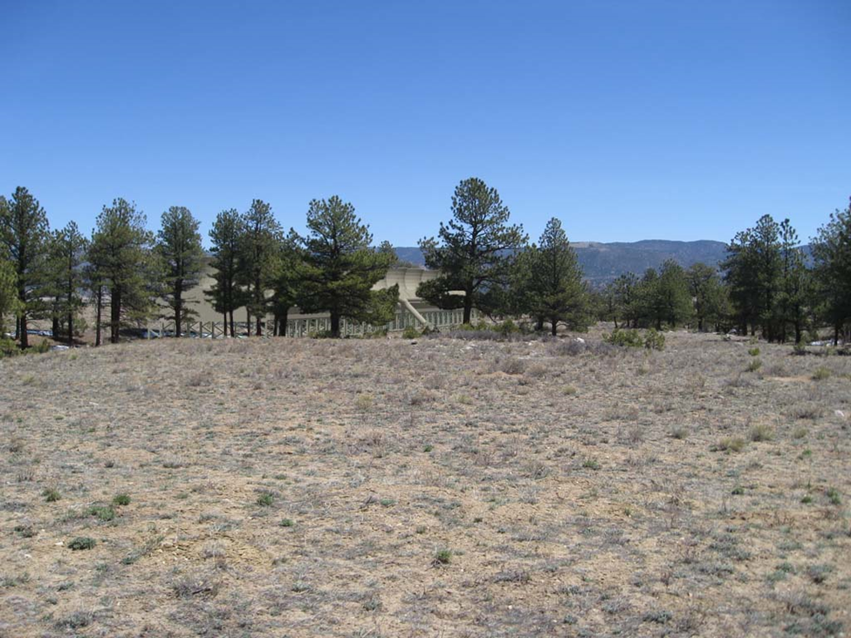

Example of 10 MW Geothermal Power Plant Integrated into Its Surroundings.

Negative impacts on socioeconomics or environmental risks would be minimized by implementing best management practices through conditions of approval for any future exploration, drilling, utilization, and reclamation and abandonment, in accordance with Chaffee County Geothermal Development guidelines, Section 1041.

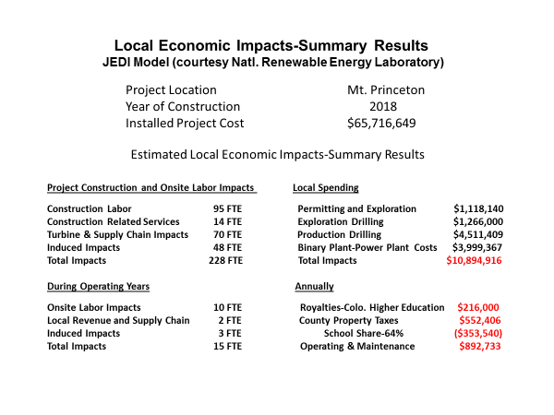

- Environmental Considerations

When compared to other energy sources such as coal, natural gas, and even some renewables, geothermal energy emerges as one of the cleanest and most environmentally benign forms of energy. In general, geothermal plants have small land footprints and low air emissions. But declines in fossil fuel prices, waning public interest in energy policy, expiration of tax credits and other incentives, and substantially decreased government funding have precipitated a dramatic decline in new geothermal development.

Today, geothermal power is underutilized for a number of reasons. Federal tax credits, which tend to be modified every few years, have reached their expiration dates. For geothermal plants with long lead times, the legislative uncertainty means the effects of the incentive are diminished. While renewable energy procurement practices tend to compare renewable energy resource alternatives against one another on a cost per kilowatt-hour (kWh) basis without considering the full range of system costs that competing technologies offer, the lack of uniformity among geothermal plants is actually a strength, because geothermal projects can provide the highest value of service tailored to the operating environment and operational needs of the market. Geothermal energy offers significant benefits in addition to a competitive cost per kilowatt-hour. One of the significant benefits of geothermal energy, besides its incredibly high capacity factor (24/7), is its extremely low air emission rate.

- Binary Power Plant

Binary geothermal plants such as those scheduled for use by Mt. Princeton Geothermal have made it possible to produce electricity from resources lower than 200°C. These new plants have greatly expanded the U.S. industry’s geographical footprint, especially in the last decade. In binary systems, geothermal water is passed through a heat exchanger in order to heat another liquid called a working fluid, which boils at a lower temperature than water. When the working fluid vaporizes, the force of the expanding vapor turns the turbines to power the generators. The geothermal water is then injected back into the reservoir in a closed loop system that is separated from groundwater sources. Because binary plants use closed-loop systems, these plants boast near-zero emissions. Recently, most new plants that have come online in the U.S. have been binary systems.

Table 1. Emissions Levels by Pollutant and Energy Source
[lbs/MWh] | BINARY | NATURAL GAS | COAL
CO₂ | - | 861.1 | 2200
N₂O | - | 0.0017 | 0.0367
SO₂ | - | 0.0043 | 18.75
Source: Climate Registry 2012, EIA 2013c, EPA 2009, EPA 2011, NRC 2010

Carbon Dioxide (CO2) Binary plants with air cooling are a closed-loop system and emit no carbon dioxide, as geothermal fluids are never exposed to the atmosphere. However, even without discounting the non-anthropogenic emissions the overall comparative amount of CO2 from geothermal plants is from small to nil, depending on technology utilized with binary power technology emitting essentially zero GHG emissions.

Nitrogen Oxide (N₂O) Since geothermal power plants do not burn fossil fuels, they emit very low levels of nitrous oxide.

Sulfur Dioxide (SO₂) Binary geothermal power plants generally release no hydrogen sulfide or sulfur emissions since they are closed loop.

ANNUAL AVOIDED EMMISSIONS(10MW)*

Offset-Grid Electricity (kWh) Emission Reduction
(Metric Tons)
C0₂ NO_{x} SO_{x}
(116,636,849) (116,537) (2) (993)

Emissions Reduction Metric Tons Environmental Equivalent
(Over COAL)
Combined Greenhouse Gases) 117,532 25,007 CARS
138,273 Acres of Trees

* https://www.epa.gov/energy/greenhouse-gases-equivalencies-calculator-calculations-and-references

