ENVISION CHAFFEE COUNTY
Vision 3: A friendly supportive community where participation is encourages and shared cultural elements connect us
How Might We: Identify measures of community strength and cohesiveness

Insights:
“The purpose of community is to connect people to each other and create value for all parties involved.”
“Community Vitality measures the strength, activity and inclusiveness of relationships between residents, private sector, public sector and civil society organizations that fosters individual and collective wellbeing.”
“Measure what the community cares about and tracks whether a community is moving in the right direction.”
Example of “Domains of Well Being” we might consider? (Smithers WA)
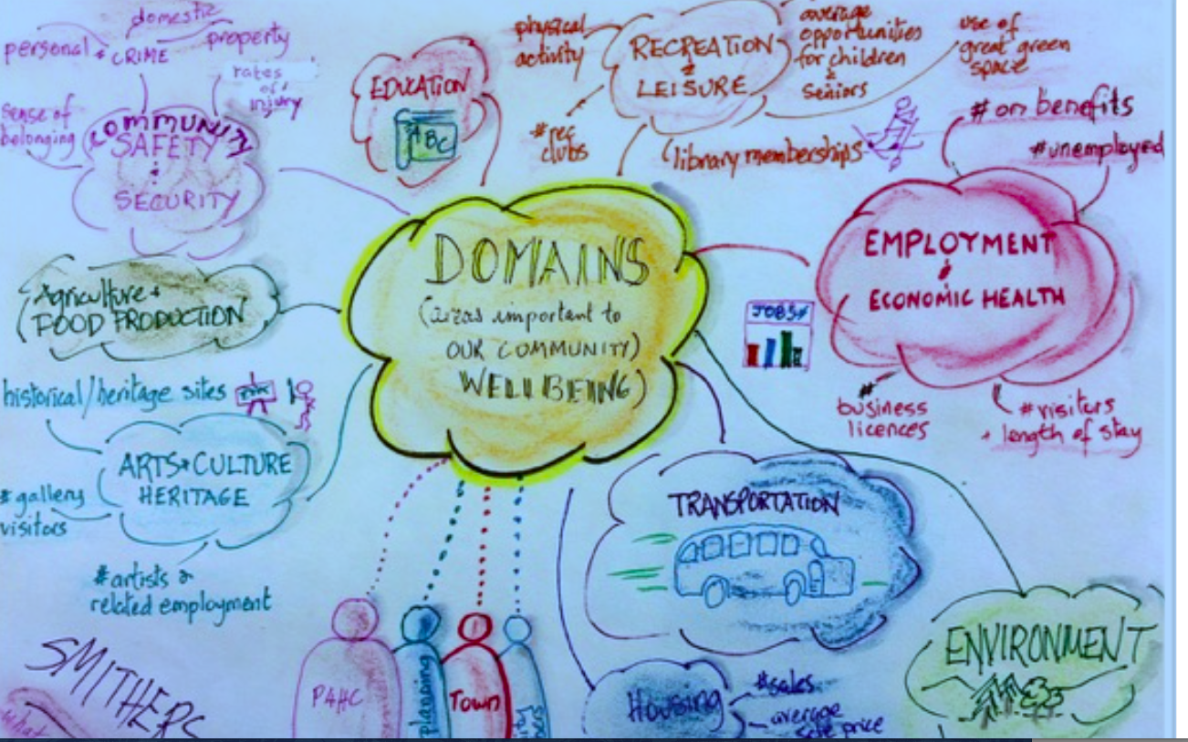

Domains considered in the Envision Report Card #3
1. Community lives locally: second homes; vrbo growth, commuters, avg. age
2. Local Business Health: Chamber member growth
3. Crime Rate (eg; Safety & Security): # offenses
4.Volunteerisms: #non-profits, volunteer hrs.

Note: Seems like #1 and #2 fit better with vision #2(able to live locally and benefit from diversified community) rather than #3

What domains do we think we should consider and possible measures?
- General /Overall Satisfaction with living here
- Subjective rating of satisfaction with our community
- #Second home owners planning (or have already) moved here
- # and reasons given by folks for move to Salida; for those who leave
- Sense of belonging and empowerment
- # volunteers: Changes in # participating over time; extent of mixing of folks from both “sides”
- belief that one’s voice/opinion is heard, that one can affect the community via personal action: attendance/participation in public meetings
- places/venues for folks to gather
- # and growth of non-profits; belief that help is available and affordable
- opportunities/ease for new comers to integrate into the community
- engagement in local gov’t: voting, attending and speaking at gov’t meetings
- Free/low-cost venues for groups to gather
- Shared values yet respect for differences
- Participation in heritage events: parades, fibark, paddlefest,county fair, Garna, etc. rates) especially those that draw people from both “sides” of our “cultural divide in # participating over time
- Letters to editor: complaints vs. compliments
- Civil discourse during public meetings , in-print, and social media
- # ,diversity (and participation) of clubs/associations
- Safety & Security
- Measures of crime rates
- Measures of response time, complaints, compliments
- No/little need to lock doors; allow children to walk to events?

5. Public and business services provided
- satisfaction with public services: roads, health, police/safety etc.
- complaints/compliments
- extent of “buying local”
- # and growth of non-profits; belief that help is available and affordable from them.;
6. Education opportunities;
- satisfaction with public schools and adult ed/enrichment opportunites.
- Measure of student performance (academic % extra-curriuclar)
7. Recreations and leisure opportunities
- #, variety, and accessibility of affordable opportunities for significant subgroups: children, teens, working adults, seniors
- # ,,diversity (and participation) of clubs/associations
- activities that bring diverse people together
8. others?

POSSIBLE NEXT STEPS
- Decide if these are the right dimension to measure.
- Seek objective data where possible
- Draft a survey questionnaire to measure subjective satisfaction on other dimensions.
- “pre-test” it on a small group and revise
- Get a “representative sample of people to respond—might consider sampling by key subgroups, eg. by length of residence; by age; by SES proxy . All of these are difficult to achieve.

Useful Web links the team might read/review
- https://ctb.ku.edu/en/table-of-contents/evaluate/evaluate-community-initiatives/member-satisfaction/main
https://www.smithers.ca/uploads/thinkpiece.pdf

Irv Broudy 2/6/18

