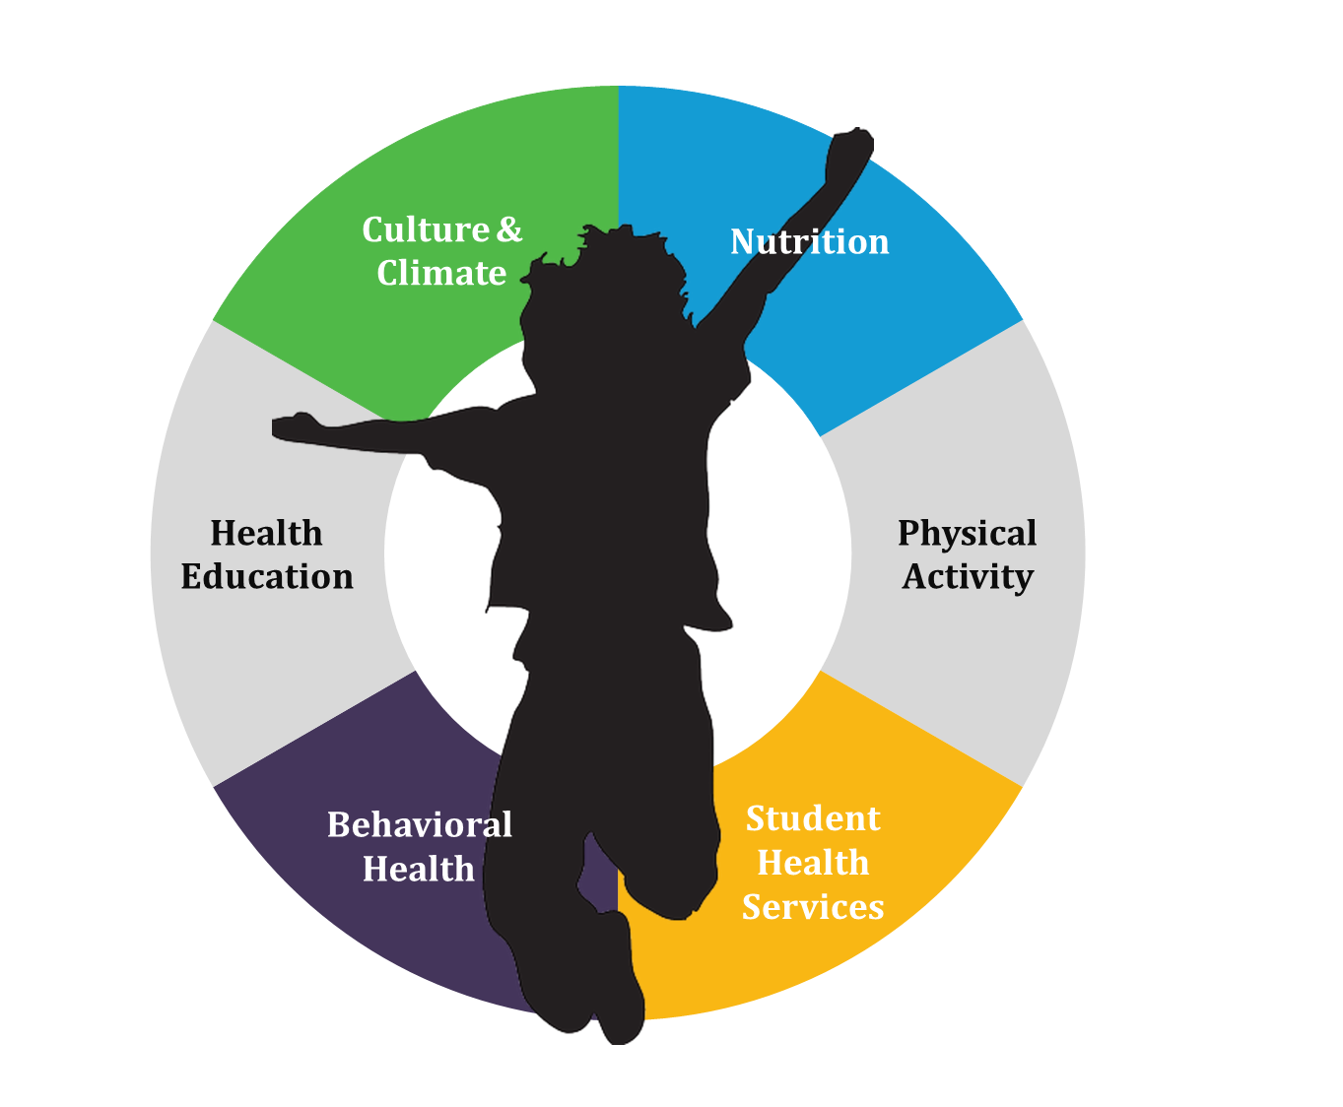
Healthy Schools Collective Impact
Sustainable Funding and Resources Group Charter

Contents
Purpose 3
Partnership Principles 5
Structure 6
Membership 7
Meeting Schedule & Commitment 9
Meeting Norms 10
Contact Information 11

Purpose
The purpose of the Healthy Schools Sustainable Funding and Resources Group is to equitably coordinate, align and provide funding and resources to support health and wellness in schools. As a critical component of the Healthy Schools Collective Impact (HSCI) structure, the funders group works to support the HSCI bold goal, vision and funding outcome:
- Funders Group End of the Road: By 2025 school health and wellness funding and resources are equitably and strategically aligned to be responsive to local school and district needs in Colorado.
- HSCI Bold Goal: By 2025, all Colorado K-12 public schools provide an environment and culture that integrates health and wellness equitably for students and staff.
- HSCI Vision: All Colorado youth are healthy and reach their full potential.
- HSCI Funding Outcome: Districts, state agencies & other funders effectively collaborate to ensure health and wellness is a priority in schools and is sufficiently resourced.
Supporting Statements
We have an opportunity to make Colorado a national leader in equitably supporting child and youth health and wellness. Working together we can:
- Be more responsive and quicker to adapt to local school and district needs;
- Better identify gaps in funding;
- Leverage our resources for less duplication and more coverage;
- Align funding application, reporting and other requirements to reduce burden on schools and districts; and
- Be more agile in leveraging opportunities for Colorado schools to access national funding.
Scope
The funders group is committed to understanding and being responsive to the needs of local schools and districts. The scope of this funders group should be in response to what’s needed to equitably address funding and resource gaps across the state. Therefore, the defining parameters listed below should be taken as current sideboards but in no way should deter critical funding partners from joining the group, especially as they are being responsive to school health and wellness needs and gaps.
- K-12, with deliberate connections and partnerships with early childhood and post high school to age 25 funders and funding groups.
- All public schools (inclusive of charters)
- Focused on school health and wellness, inclusive of all aspects of the Whole School, Whole Community, Whole Child (WSCC) model, with the consideration that “whole child” language may resonate more with funders promoting academic performance. Not limited to only the strategies within the HSCI strategic action plan.
- Within the school community, before and after school time included, community partners supporting referrals from schools
- Groups directly funding schools/districts as well as funding going to orgs/agencies providing services in schools and during the school day.

Partnership Principles
Partnership principles guide our work and the way we interact with each other.
TRUST AND RESPECT
Assume positive intent and trust that partners have the best interest of the group in mind
CREATIVITY AND INNOVATION
Recognize that we will need to do things differently and change the way we work in order to achieve our goals
OPEN AND TRANSPARENT COMMUNICATION
Bold enough to say what we think even if it goes against the grain
COMMITMENT TO THE BOLD GOAL
We commit to setting aside our personal biases to let the bold goal be the collaboration’s driving force

MUTUAL ACCOUNTABILITY
Hold ourselves and one another accountable to participating fully

Structure
The diagram below outlines the current HSCI structure and how the Sustainable Funding and Resources Group fits within it. It may be updated as input is received and the work progresses so that it is responsive to the needs of the initiative.
HEALTHY SCHOOLS NETWORK
EQUITY GROUP
IDEAS

Colorado Alliance for School Health

AFFILIATED GROUPS

Other Work Groups TBD

BACKBONE SUPPORT
EVALUATION
Communications, Marketing & Engagement

Professional Development
WORK GROUPS
SUSTAINABLE FUNDING AND RESOURCES GROUP
STEERING COMMITTEE
& SPRINT GROUPS

WORK GROUP REP COUNCIL
Backbone support
The purpose of the backbone is to act as a neutral entity to guide, coordinate, and support the initiative, including the Sustainable Funding and Resources Group. Spark Policy Institute is the current backbone and supports the system & Steering Committee priorities through facilitation, logistics, documentation and strategic thought partnership.

Membership
Early Members
- The Colorado Health Foundation: Dara Hessee
- Kaiser Permanente: Carmen Martin and Curtis Robbins
- Colorado Department of Education (CDE): Karina Delaney, Sarah Mathew and/or Phyllis Reed
- Colorado Department of Human Services (CDHS): Pearl Bell
- Colorado Department of Public Health and Environment (CDPHE): Lorin Scott-Okerblom and/or others from CDPHE
- Gates Family Foundation: Ana Soler

- Early funders to engage (this list represents a sample of critical initial perspectives to engage but is not exclusive or comprehensive in its current form:
  - Governor’s office
  - Healthcare Policy and Finance (HCPF), School Health Medicaid Services
  - CDPHE (other funders)
  - CDHS (other funders)
  - Attorney General’s office (Safe to Tell)
  - Gill Foundation
  - Rose Community Foundation
  - Walton Family Foundation
  - The Colorado Trust
  - The Denver Foundation
- Please see attached for a more comprehensive list of potential funders to engage over time.
Criteria & Ideas to Consider for Engaging Additional Funders
- Start with the big players and then have them help determine other funders to engage
- Amount of funding and resources they offer and what they fund (planning, implementation, capacity building, FTE, physical infrastructure, etc.)
- Geographic scope and reach of funding (national vs. statewide vs. regional) – may want to engage with local affiliates and partners of national funders
- Scale of funding - school based funding vs. district based funding vs. community based funding vs. statewide system funding
- Want to engage direct funders initially rather than intermediaries
- Who has the capacity to engage with this group and how do we engage others that may not be able to participate in the same way?
- Ensure that this criteria reflects what schools and districts need for funding and resources
Outreach
- Focus initial efforts on early funders to engage
- Determine who in the Steering Committee and HSCI network already has connections with these funding partners for a warm outreach to join the group.
- Ensure that those in the group and outreaching to other funders are clear about the purpose of the group and that they can articulate the value of participating
- Ensure clarity around non-competitive nature of the group
- Eventually plan for engaging nontraditional funders (sport teams, etc.)
- Consider Colorado’s unique position related to marijuana dollars in the funding environment (drug & alcohol prevention, etc.) – connect with the governor’s office on this opportunity

Meeting Schedule & Commitment

- 11/30 from 1-2:30pm
- 12/14 from 1-2:30pm
- 1/18 from 1-2:30pm
- 2/15 from 1-2:30pm
- 3/15 from 1-2:30pm
- 4/19 from 1-2:30pm
- 5/17 from 1-2:30pm
- 6/21 from 1-2:30pm

Meeting Norms
- Start and end on time
- Silence cell phones and step out of the room for important phone calls
- Minimize ‘outside’ business during sessions
- Honor commitments to the group and work between meetings
- Be willing to step up and also step back
- Express genuine feelings concisely
- Focus on solutions: share your concerns, but try to follow up with a proposed solution
- Actively listen to one another’s viewpoints
- Address conflict during meetings, dealing with the issue, not the person
- Respect one another by avoiding side conversations or interrupting when someone is speaking
- Remember and engage remote participants
- If discussion becomes relevant to only a few participants or to another subgroup, hold the discussion outside of the meeting to be handled by relevant parties
- Topics outside the agenda will be documented and tabled for a later time (i.e. a future meeting or a subgroup to discuss between meetings)
- Decision Making Process:
  - Voting will include those present in the room and on the phone
    - For non-present members, the decision will be communicated to them after the meeting. They will have the opportunity to state whether they have MAJOR concerns with the decision. If so, the group may choose to revisit the decision. If not, the decision made during the meeting stands.
  - Every person in the room will be asked for input individually before voting for major decisions
  - Make decisions by thumbs up, thumbs down, thumbs sideways:
    - Thumbs up: vote to pass the decision, in favor of
    - Sideways thumb: won’t block the decision, need clarification or are unsure
    - Thumbs down: vote to block the decision, not in favor of
  - Passage percentage
    - 65%+ thumbs up: passage
    - 65%+ thumbs down: blocked
    - Any other combination of voting will warrant additional discussion
- Review norms at each meeting
- Group will periodically reassess meeting norm effectiveness every 6 months; add, delete, or renegotiate norms as needed

Contact Information
Name | Organization | Email | Phone
Pearl Bell | Colorado Department of Human Services (CDHS) | pearl.bell@state.co.us | 303-866-4706
Cari Davis | Colorado Springs Health Foundation | cdavis@cshf.net | 719-985-8989
Dara Hessee | The Colorado Health Foundation | dhessee@coloradohealth.org | 303-953-3641
Katelyn Lammie | Caring for Colorado | klammie@caringforcolorado.org | 303-866-3131
Carmen Martin | Kaiser Permanente | Carmen.R.Martin@kp.org | 303-525-2518
Sarah Mathew and/or Phyllis Reed | Colorado Department of Education (CDE) | mathew_s@cde.state.co.us  Reed_P@cde.state.co.us | 303-866-6903 303-866-6593
Antonio Pares | Donnell-Kay Foundation | apares@dkfoundation.org | 303-718-3352
Curtis Robbins | Kaiser Permanente | curtis.j.robbins@kp.org | 303-229-4722
Lorin Scott-Okerblom | Colorado Department of Public Health & Environment (CDPHE) | lorin.scott-okerblom@state.co.us | 303-691-4073
Ana Soler | Gates Family Foundation | asoler@gatesfamilyfoundation.org | 303-316-3017
Meggan Parezo | Spark Policy Institute (Backbone support) | Meggan@sparkpolicy.com | 303-455-1740

