SWFI Child Care Learning Community
Community College of Aurora Lowry Campus
710 Alton Way
September 11, 2017 1:00PM – 3:00PM

Meeting Outcomes:
- Understand how we will use the Community Learning Model over the next year to guide our work.
- Develop shared understanding and vocabulary for results, indicators, and performance measures.
- Reach agreement on a set of results and indicators to guide this work and begin to fill in our action map.

1:00 PM | Opening | Janel Highfill, Community College of Aurora  Keri Batchelder, Colorado Dept. of Human Services
1:20 PM | Using the Community  Learning Model to Guide Our Journey | Bill Fulton, Civic Canopy
1:35 PM | Results Thinking & Language | Bill Fulton, Civic Canopy
1:55 PM | Defining Shared Results and Indicators | Full Group
2:40 PM | Preview of Next Steps | Bill Fulton, Civic Canopy  Rich Jones, Bell Policy
3:00 PM | Meeting Evaluation & Close | Bill Fulton, Civic Canopy

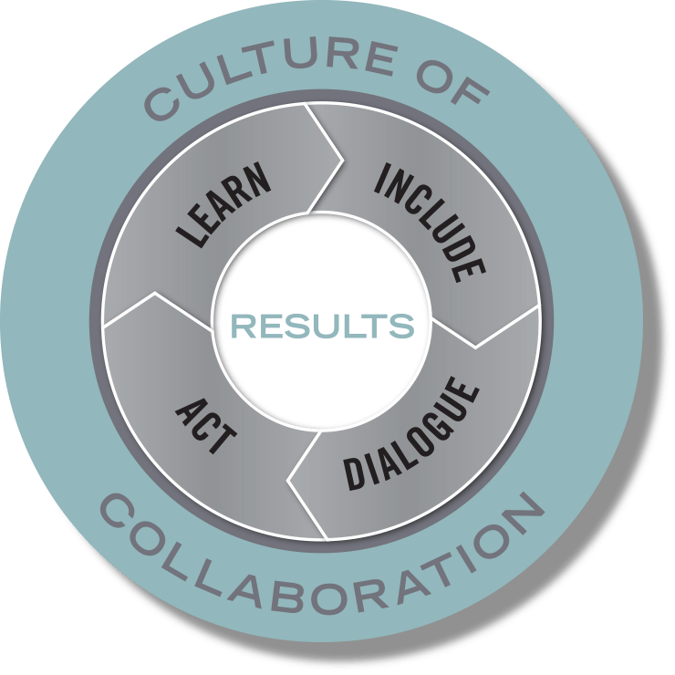

The SWFI Child Care Learning Community’s Guiding Principles

During the initial meeting of the SWFI Child Care Learning Community on June 12, 2017, the group discussed what they believed to be possible through the efforts of the Learning Community. Specifically, they were asked to discuss the results they hoped to accomplish together and strategies they thought could produce those results. While some concrete strategies and outcomes were identified, the majority of the conversation was about the nature, characteristics, qualities, and values that they hoped would be true of the process and outcomes. There were common themes that emerged from the small groups conversations. These themes revealed the collective values of the group and serve as principles to guide the Learning Community’s decisions and efforts.

We commit to using the following guiding principles, developed by the Learning Community, as a checklist to filter ideas and solutions though during decision-making processes.

- Solutions are sustainable
- Solutions are scalable
- Solutions improve systems
- Solutions address root causes and barriers
- Solutions respond to students’ lived experiences and goals
- Solutions considers a variety of care models to honor student choice
- Solutions promotes partnership and collaboration

