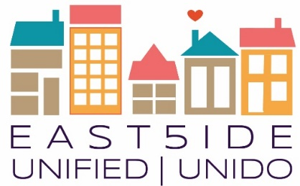
East5ide Unified|Unido is a community-driven effort to ensure all children in five Northeast Denver neighborhoods are valued, healthy & thriving by leveling the playing field before they start school.

Clayton - Cole - Five Points - Skyland/North City Park - Whittier

Let’s Talk Health (Care):
Hospitals, Clinics and YOU

Please join us for a community conversation with health care leaders from Denver Health, Kaiser Permanente, Presbyterian St. Lukes, and
St. Joseph Hospital.

Facilitated by Geri Grimes, Executive Director of Hope Center and East5ide Unified Council member.

September 12, 5:00-7:00pm
Blair Caldwell African American Library
2401 Welton Street, Denver, CO 80205

The event is free, please register atEventbrite: https://eu_topicseries09-2017.eventbrite.com

Appetizers and dessert will be provided; the building is ADA accessible. Questions? Email earlychildhood@civiccanopy.org or
call 303-292-3144 x217

Spanish Interpretation will be provided.
Please share this invitation with family, friends, neighbors and colleagues. All are welcome!
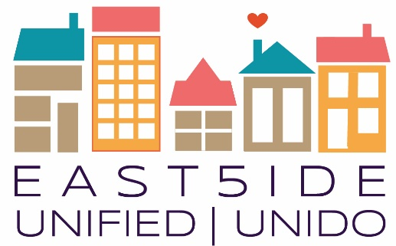
About East5ide Unified|Unido

Clayton ● Cole ● Five Points ● Skyland/North City Park ● Whittier

What happens when you turn things upsidedown and put families, residents, and community partners in the driver’s seat to affect change for young children in their community?

We all play a role in supporting strong children, families and communities. East5ide Unified, a project of the BUILD Health Challenge, aims to build a thriving network of support systems and a community-wide commitment young children so they can succeed in school and in life.
Want to take action for children and families in YOUR community?

Join an East5ide Unified Workgroup to drive our activities

Attend a Topic Series event to learn more about important issues affecting the 80205 community

Support East5ide Street Teams and connect with residents

Sign up for the email list to learn more and receive updates
Learn more: east5ideunified.org

Want to receive ongoing updates and information on East5ide Unified?
Email earlychildhood@civiccanopy.org to be added to the email list!
Find us on Facebook!

