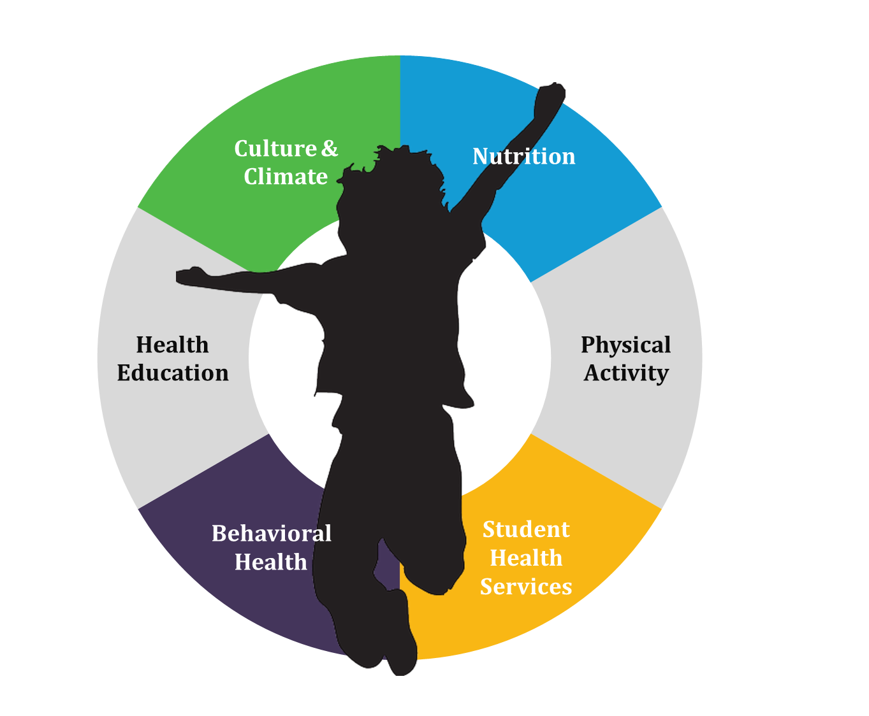
Healthy Schools Collective Impact
Steering Committee Charter

Contents
Welcome! 3
Partnership Principles 4
HSCI History and Background 5
Structure 6
Steering Committee 6
Steering Committee Sprint Group 6
Work Groups 7
Funders 7
Backbone 7
Evaluation Team 7
Steering Committee Roles & Responsibilities 8
Vision, Connection, and Guidance 8
Vision 8
Connection 8
Guidance 8
Leadership 9
HSCI Relationships 9
Steering Committee Members & Contact Information 12
Meeting Norms 14

Welcome!

Welcome to the Healthy Schools Collective Impact (HSCI) Steering Committee! The charge of HSCI is to align the overall healthy schools system and transform the system across behavioral health, student health services, physical activity, nutrition, school culture and climate, and health education. Everything we do is in service of better outcomes for students and staff.
HSCI is driven by an overall approach and outcomes that advance health equity, recognize and respond to differentiated needs, and helps schools meet their educational goals. HSCI defines health equity as: when all students, no matter what their social position, have the opportunity to attain their full health potential and be ready to learn. Achieving health equity requires valuing all students equally with focused and ongoing efforts to address systemic and avoidable inequalities, including historical and contemporary injustices.

Bold Goal: By 2025, all Colorado K-12 public schools provide an environment and culture that integrates health and wellness equitably for students and staff.
Vision: All Colorado youth are healthy and reach their full potential.

Partnership Principles
Partnership principles guide our work and the way we interact with each other.
OPEN AND TRANSPARENT COMMUNICATION
Bold enough to say what we think even if it goes against the grain
CREATIVITY AND INNOVATION
Recognize that we will need to do things differently and change the way we work in order to achieve our goals
COMMITMENT TO THE BOLD GOAL
We commit to setting aside our personal biases to let the bold goal be the collaboration’s driving force

MUTUAL ACCOUNTABILITY
Hold ourselves and one another accountable to participating fully
TRUST AND RESPECT
Assume positive intent and trust that partners have the best interest of the group in mind

HSCI History and Background
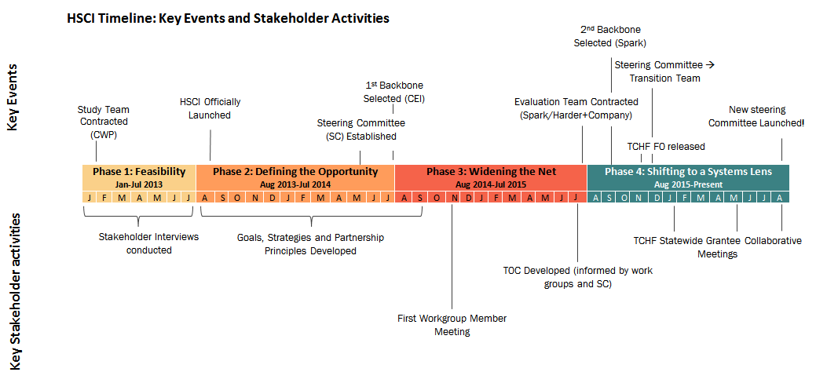
CEI = Colorado Education Initiative
CWP = Community Wealth Partners
FO = Funding Opportunity
TCHF = The Colorado Health Foundation
TOC = Theory of Change

Structure

The diagram below outlines the Healthy Schools Collective Impact (HSCI) draft structure. It may be updated as input is received and the work progresses so that it is responsive to the needs of the initiative.
Other Work Groups

HEALTHY SCHOOLS NETWORK

SPRINT GROUP

BACKBONE SUPPORT: Spark Policy Institute
EVALUATION
Communications, Marketing & Engagement

Professional Development
Policy

Data Systems, Research & Evaluation

EVALUATION ADVISORY COUNCIL (TBD)
Funders Table
Colorado Alliance for School Health
Work Group Reps Council
Local Advisory Council (TBD)

WORK GROUPS
OTHER
SUB-COMMITTEES
STEERING COMMITEE

ADVISORY GROUPS

Steering Committee
To purpose of the Steering Committee is to set the strategic direction and policy priorities of HSCI and ensure work done is in service of that direction and priorities. The Steering Committee is composed of 15-20 leaders with influence in their respective networks and ability to inform/make systems-level decisions on behalf of their organization, community, school, family, etc. Roles and responsibilities include:
- Representing HSCI values and commitments;
- Promoting HSCI efforts and communicating its progress to their networks;
- Advocating for alignment with HSCI’s strategic direction and priorities within their organization, community, school, etc.; and
- Making high-level decisions about strategy & policy priorities.

Steering Committee Sprint Group
The Sprint Group is a short-term subgroup of the Steering Committee. Its purpose is to develop recommendations that assist the Steering Committee in making decisions regarding HSCI governance, structure, engagement, and accountability to support an equitable, high quality and action-oriented Steering Committee.

Work Groups
The intent of Work Groups is to actualize the direction and policy priorities set by the Steering Committee, as well as inform the work of the Steering Committee. These are action-oriented teams with the “boots on the ground” perspective. The Steering Committee will review the proposal to adopt the Creating Healthy Schools funding strategy’s Statewide Systems function areas as HSCI work groups (TBD by at 9/26/2016 meeting).

Funders
While funders are not an official HSCI group, they are important partners to ensure sustainable and diversified financial support for the initiative. Part of the work of the Steering Committee will be to engage and sustain diverse funders.

Backbone
The purpose of the backbone is to act as a neutral entity to guide, coordinate, and support the initiative. Spark Policy Institute is the current backbone. Prior to Spark, Colorado Education Initiative was in this role. Roles and responsibilities of the backbone include:
- Supporting stakeholders to operationalize and implement the strategic direction set by the Steering Committee;
- Facilitating Steering Committee meetings;
- Maintaining documentation of the work;
- Communicating and coordinating between all groups; and
- Championing alignment within and outside the initiative.

Evaluation Team
The purpose of the evaluation team – composed of Harder+Company and Spark Policy Institute is to determine progress towards goals, initiative effectiveness, and both short- and long-term impact. Their roles and responsibilities include:
- Collecting, compiling, and presenting information to guide HSCI in data-based decision making;
- Informing areas of focus and strategies, as well as helping surface group dynamics;
- Ensuring HSCI is grounded in best practices and continuous learning; and
- Supporting the creation, implementation, and maintenance of a shared measurement system.

Steering Committee Roles & Responsibilities
The Healthy Schools Collective Impact (HSCI) Steering Committee works to reach HSCI’s bold goal and vision.
- Bold goal: By 2025, all Colorado K-12 public schools provide an environment and culture that integrates health and wellness equitably for all students and staff.
- Vision: All Colorado youth are healthy and reach their full potential.
- Our Partnership Principles guide the way we work with each other
Steering Committee roles responsibilities can be divided into:
- The collective roles and responsibilities of the Steering Committee as one entity; and
- The roles and responsibilities of individual Steering Committee members.

Vision, Connection, and Guidance
The collective roles and responsibilities of the Steering Committee as one entity
Vision
The HSCI Steering Committee is responsible for guiding efforts towards a shared vision and work towards our bold goal by:
- Tracking progress of work using agreed-upon indicators
- Preventing and preparing for shocks to the system
- Balancing bold innovative long-term strategies with actionable short-term strategies, including via policy priorities
- Leveraging the Discretionary Fund to support the work*
- Providing oversight to the backbone
- Championing collaboration & alignment to help system partners avoid siloing work
Connection
The Steering Committee champions a common purpose for systemic change by strengthening collaborative relationships by:
- Making connections between work groups to ensure coordination and efficiency
- Engaging partners and community members to amplify, leverage, and support work in service of the bold goal and vision
- Engaging funders to support work in service of the bold goal and vision as well as collaboration between partners
Guidance
While working on vision and connection, the Steering Committee will prioritize:
- Considering a balance of student health services, comprehensive physical activity, nutrition, behavioral health, and schools climate & culture
- Being informed by data and best practices and using these to inform systems level decision-making and learning
- Addressing equity
- Being informed by and accountable to local/on-the-ground perspectives
- Addressing health & wellness through a framework of Whole School, Whole Community, Whole Child
The backbone assists the Steering Committee in creating tools/activities/processes to fulfill these responsibilities and to ensure HSCI priorities are addressed and considered during the implementation of the work.
*Discretionary Fund
The HSCI Discretionary Fund is a pool of funds (roughly $65k as of July 2016) that:
- Helps support or advance the HSCI bold goal and work defined in the HSCI agenda
- Helps the work move quickly and drive toward outcomes
- Supports the HSCI emphasis on health equity
- Supports a function that is not already filled by the existing Steering Committee, Work Groups, backbone, evaluation group, etc.
Decision making process for use of the discretionary fund and proposed uses to date are outlined in the Steering Committee Onboarding Packet.

Leadership
The roles and responsibilities of individual Steering Committee members
Steering Committee members:
- Advocate for alignment towards the HSCI vision and bold goal within your organization, community, school, etc.
- Promote HSCI efforts and communicate its progress to your network
- Represent HSCI values and commitments
- Make high-level decisions about strategy & policy priorities
- Participate in regularly scheduled meetings, in person whenever possible
- Pre-read materials prior to meetings and come prepared for engaged discussion, active listening, and respectful dialogue
- Share responsibility for in between meeting work, including staffing subcommittees when needed

HSCI Relationships
The table below outlines the way the components of the structure in the first column interact with the components of the top row and/or the purpose of their relationship. E.g. 1B is how the Steering Committee interacts with the Local Advisory Council, while 2A is how the Local Advisory Council interacts with the Steering Committee. Please note that each component may share membership with another.
 | Steering Committee | Local Advisory Council | WG Rep Council | Work Groups | Backbone | Eval. Team | G. Eval. Advisory Council | H. Healthy Schools Network
Steering Committee |  | SC may vet strategic direction decisions or policy opps with Council for on-the-ground perspective. | SC promotes cross-WG communication & alignment, guide work in service of vision | SC members may inform WGs around vision or alignment if interaction beyond WG rep council is needed | SC provides backbone oversight. | SC informs the evaluation plan and makes adjustments to the strategic direction based on learnings. |  | SC may share HSCI updates via the HSCI newsletter or at quarterly meetings
Local Advisory Council | Local council keeps the SC’s work rooted in on-the-ground realities & its focus on building a system to meet local need. |  | Local council keeps WGs rooted in on-the-ground realities & its focus on building a system to meet local need by informing reps. | Local council may inform WGs if interaction beyond WG rep council is needed. | Local council may alert that backbone to needed communications, processes, etc. | Local council informs the feedback loop components of the evaluation.
WG Rep Council | WG rep council gives input on overarching work and strategic direction | WG rep council may vet decisions & actions with the Local Council for on-the-ground perspective. |  | Represents WGs and promotes cross-WG communication & alignment | WG rep council may call on backbone for logistics support & needed comms, processes, etc. | WG rep council informs evaluation learning in a targeted way via representatives and make adjustments to work based on learnings.
Work Groups | WGs may share updates of their work with SC if interaction beyond WG rep council is needed | WGs may share updates with local council or solicit input if interaction beyond WG rep council is needed | WGs may funnel concerns, questions, ideas, etc. to WG rep council for cross-WG or steering committee consideration. |  | WGs may call on backbone for logistics support and needed communications, processes, etc. | WGs may inform evaluation learning if interaction beyond WG rep council is needed and make adjustments to work based on learnings. | Data systems, Research, and Evaluation WG member will be on advisory council to ensure alignment & minimal duplication of work | WGs may share HSCI updates via the HSCI newsletter or at quarterly meetings
Backbone | Backbone supports SC’s work via processes, logistics, etc. | Backbone convenes local council(s) | Backbone convenes WG rep council | Backbone may support WG logistics, processes, etc. |  | Backbone informs evaluation plan and makes adjustments to processes and supports based on learnings. |  | Backbone may share HSCI updates during the quarterly meetings in addition to monthly newsletter
Eval. Team | Evaluation team shares learning with SC to improve direction, work & processes and promote accountability | Evaluation team may gather input from and share learning with local council(s) | Evaluation team may gather input from and will share learning with WG rep council as well as coordinate with WG data collection efforts | Evaluation team may share learning and/or engage WGs in data collection. | Evaluation team will share learning and coordinate dissemination of learning with backbone. |  | Evaluation team will vet evaluation activities with eval advisory council to ensure relevant and value-add evaluation results
Eval. Advisory Council |  |  |  | Eval advisory council will stay informed of the Data Systems, Research, and Evaluation WG’s work to ensure alignment & minimal duplication of work |  | Eval advisory council will inform evaluation activities to ensure relevant and value-add evaluation results
Healthy Schools Network |  |  |  | May participate on WGs intermittently if specific perspective is needed | Can inform content of monthly newsletter

Steering Committee Members & Contact Information
Name | Organization | Email | Phone
Steering Committee Members
Alejandra Venzor | Colorado Department of Education | venzor_a@cde.state.co.us | 303-866-6454
Amy Dyett | Colorado Education Initiative | adyett@coloradoedinitiative.org | 720-502-4716
Audra Bishop | Colorado Department of Public Health and Environment | audra.bishop@state.co.us | 303-691-4936
Becky McLean | Academy 360 | rebecca@academy-360.org | 720-336-0320
Curtis Robbins | Kaiser Permanente | curtis.j.robbins@kp.org | 303-229-4722
Elaine Belansky | Rocky Mountain Prevention Research Center | elaine.belansky@ucdenver.edu | 720-530-3642
Jamie Hurley | RMC Health | jamesh@rmc.org | 303-621-5569
Laura McArthur | Aurora Mental Health Center | lauramcarthur@aumhc.org | 303-617-2752
Lorrie Odom | CO PTA & Jeffco Council PTA | lorrieodom@comcast.net | 303-944-7680
Omar Estrada | Colorado Department of Education | estrada_o@cde.state.co.us
Sarah Mathew | Colorado Department of Education | mathew_s@cde.state.co.us | 267-240-9764
Stephanie Wasserman | Colorado Children's Immunization Coalition | stephanie.wasserman@childrenscolorado.org | 720-777-3270
Susan Rowley | Boulder Valley School District | susan.rowley@bvsd.org | 720-561-5543
Youth Advisor - TBD | Colorado Department of Public Health and Environment
Backbone Team
Meggan Parezo | Spark Policy Institute | Meggan@sparkpolicy.com | 303-455-1740 x 114
Alison McCarthy | Spark Policy Institute | Alison@sparkpolicy.com | 303-455-1740 x 125
Evaluation Team
Jewlya Lynn | Spark Policy Institute | jewla@sparkpolicy.com | 303-455-1740 x 113
Jennifer James | Harder+Company Community Research | jjames@harderco.com | 619-398-1980

Meeting Norms
- Start and end on time
- Silence cell phones and step out of the room for important phone calls
- Minimize ‘outside’ business during sessions
- Honor commitments to the steering committee and work between meetings
- Be willing to step up and also step back
- Express genuine feelings concisely
- Focus on solutions: share your concerns, but try to follow up with a proposed solution
- Actively listen to one another’s viewpoints
- Address conflict during meetings, dealing with the issue, not the person
- Respect one another by avoiding side conversations or interrupting when someone is speaking
- Remember and engage remote participants
- If discussion becomes relevant to only a few participants or to another subgroup, hold the discussion outside of the meeting to be handled by relevant parties
- Topics outside the agenda will be documented and tabled for a later time (i.e. a future Steering Committee meeting or for the Sprint Group to discuss between meetings)
- Decision Making Process:
  - Voting will include those present in the room and on the phone
    - For non-present members, the decision will be communicated to them after the meeting. They will have the opportunity to state whether they have MAJOR concerns with the decision. If so, the group may choose to revisit the decision. If not, the decision made during the meeting stands.
  - Every person in the room will be asked for input individually before voting for major decisions
  - Make decisions by thumbs up, thumbs down, thumbs sideways:
    - Thumbs up: vote to pass the decision, in favor of
    - Sideways thumb: won’t block the decision, need clarification or are unsure
    - Thumbs down: vote to block the decision, not in favor of
  - Passage percentage
    - 65%+ thumbs up: passage
    - 65%+ thumbs down: blocked
    - Any other combination of voting will warrant additional discussion
- Review norms at each meeting
- Sprint group will periodically reassess meeting norm effectiveness every 6 months; add, delete, or renegotiate norms as needed

Memorandum of Understanding
BETWEEN THE HEALTHY SCHOOLS COLLECTIVE IMPACT (HSCI) BACKBONE
AND [INDIVIDUAL OR ORGANIZATION]
- Parties. This Memorandum of Understanding (hereinafter referred to as “MOU”) is made and entered into by and between the Healthy Schools Collective Impact Backbone (Spark Policy Institute), and [individual or organization] .
- Purpose. The purpose of this MOU is to establish the terms and conditions under which the Healthy Schools Collective Impact Steering Committee will meet.
- Term of MOU. This MOU is effective upon the day and date last signed and executed by the duly authorized representatives of the parties to this MOU and the governing bodies of the parties’ respective counties or municipalities and shall remain in full force and effect for not longer than [time frame] This MOU may be terminated, without cause, by either party upon [time frame] written or electronic notice.
- Your Responsibilities. Each Steering Committee member will prioritize monthly meeting attendance and participation, recognizing that all other members are sacrificing their time to do the same. It will be the expectation that all materials sent to the Steering Committee prior to each meeting will be read beforehand. Each Steering Committee member agrees to operate according to the established vision, mission, values, policies, and meeting norms of HSCI.
- Spark Policy Institute’s Responsibilities. The backbone is here to facilitate Steering Committee and Sprint Group meetings in addition to providing general oversight for the parties involved in HSCI. Steering Committee members can contact the backbone with any questions, concerns or comments they may have about HSCI or their involvement in it.
- Confidentiality. Each Steering Committee member will recognize the importance of topics discussed within meetings by upholding the confidentiality of certain topics.
- Conflicts of Interest. Steering Committee members will inform the group of their personal or professional conflicts of interest that may arise within a meeting topic. Furthermore, they will not act upon said conflicts.
- General Provisions
  - Amendments. Either party may request changes to this MOU. Any changes, modifications, revisions or amendments to this MOU which are mutually agreed upon by and between the parties to this MOU shall be incorporated in writing, and effective when executed and signed by all parties to this MOU.
  - Severability. Should any portion of this MOU no longer suit your job responsibilities, scope of work, or other circumstances, then [individual or organization] will be may give Spark Policy Institute advanced notice regarding their severance.
- Signatures. In witness whereof, the parties to this MOU through their duly designated representatives—whether that be the Steering Committee member themselves or their organizations—have executed this MOU on the days and dates set out below, and certify that they have read, understood, and agreed to the terms and conditions of this MOU as set forth herein.
The effective date of this MOU is the date of the signature last affixed to this page.
[Individual/Organization]

[Name and Title ] Date

[Name and Title] Date

Healthy Schools Collective Impact Backbone

[Name and Title] Date

[Name and Title] Date

Glossary of Terms
Term | Definition
Advancing IDEAS for health | Advancing the Innovation and Dissemination of Evidence-Based Action in Schools for Health. A subset of TCHF system grantees working in the data systems, research, and evaluation function area.
Backbone | The neutral entity that guides, coordinates, and supports HSCI. Spark Policy Institute is the backbone and is contracted by TCHF’s healthy living team.
Colorado Alliance for Schools Health (CASH) | A subset of TCHF systems grantees working in the professional development & policy function areas, and focused on student health services & behavioral health.
Creating Healthy Schools | The funding strategy from The Colorado Health Foundation – the funding opportunity covered local and systems statewide funding
Creating Healthy Schools function area/function group | The four buckets of work of systems grantees are:  - Policy  - Professional development and implementation  - Data systems, research, and evaluation  - Communications, marketing, and engagement
Data & Evaluation work group | An HSCI Work Group that guides the evaluation team to meet the data and information needs throughout the initiative by:  - Developing & deploying a shared measurement system;  - Guiding the HSCI evaluation; and  - Building alignment across healthy schools evaluation efforts statewide.
Evaluation team | The group that learns about progress towards goals, effectiveness, and both short- and long-term impact for HSCI and Creating Healthy Schools grantees. This team also leads the Data & Evaluation work group. Harder+Company and Spark Policy Institute act as the evaluation team, contracted by TCHF’s evaluation team.
Healthy Schools Collective Impact (HSCI) | The initiative financially supported by TCHF and led by a newly-expanded steering committee, which aims to align work happening in Colorado in service of healthy schools and students. HSCI is working towards the goal that by 2025, all Colorado K-12 public schools provide an environment and culture that integrates health and wellness equitably for students and staff.
HSCI Steering Committee | The group that sets the strategic direction and policy priorities of HSCI, and ensures its work and the work of others in the initiative is in service of that direction. At this time, how the steering committee will interact with systems grantees is still to be determined, though some systems grantees are on the steering committee.
Local Grantees | The school districts or groups of schools funded via the Creating Healthy Schools funding opportunity to work at a local level.
Professional Development (PD) alliance | A subset of grantees working in the professional development and implementation function area.
Shared Measurement System (SMS) | A short list of key indicators/measures designed to encourage alignment of local and state efforts as well as collectively track and evaluate their progress. The Data & Evaluation Work Group, with support from the Evaluation Team, is working on HSCI’s SMS.
Systems Grantees | The organizations funded via the Creating Healthy Schools funding opportunity to work at a systems/statewide level.
TCHF | The Colorado Health Foundation
Topic area | The topic areas that are the focus of the healthy schools work:  - Nutrition (healthy food and beverages)  - Physical activity  - Student health services  - Behavioral needs  - Health education  - Culture and climates (schools are supportive of student and staff health and wellness)
Work group | Small groups that are part of HSCI and actualize the direction and policy priorities set by the Steering Committee, as well as inform the work of the Steering Committee. These are action-oriented teams with the “boots on the ground” perspective. Currently, the only active work group is the Data & Evaluation Work group.

