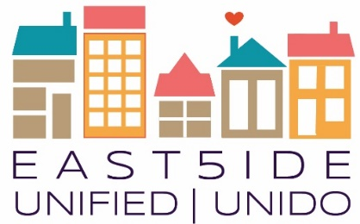
East5ide Unified|Unido is a community-driven effort to ensure all children in five Northeast Denver neighborhoods are valued, healthy & thriving by leveling the playing field before they start school.

Clayton ● Cole ● Five Points ● Skyland/North City Park ● Whittier

The Power of Connectedness: Connection begins with our relationship to parents and family - but does not end there. A healthy community is a connected one. Children, adults, families, organizations, businesses and neighborhoods require connection to self, to one another and to culture to truly thrive. To build interdependent connections will take all of us, and begins with each one of us.
Work Group Meetings
These meetings are for those who want to roll up their sleeves and take action rather than just talking. We dig into strategy, objectives, results, & possibilities in each of the following areas. Your voice is needed & welcome:
Residential Outreach: Every 2nd Tuesday @ 5:30-7:30 3532 Franklin Street, we will be placing signs on the doors to direct you to the room we are in.
Business and Organization Outreach: Every 2nd Tuesday @ 5:30-7:30 3532 Franklin St - We will be placing signs on the doors to direct you.
EU Council Meetings: July 18, 5-7pm @ 3532 Franklin Street – these meetings are open to the public to observe!

FAMILY – Fathers and Men Invested in the Lives of Youth
Our goal is to engage 1000 Men and build a core 100 Men who respond to whatever is needed for Fathers, Families, and Community

August 15 6-8pm @ St. Charles Rec 3777 Lafayette St, Denver CO 80205

September 19 6-8pm @ Epworth united Methodist 3401 High St. Denver 80205

October 17 6-8pm @ Epworth United Methodist

November 21st 6-8pm @ St. Charles Rec

December 19 6-8pm @ Epworth United Methodist
Questions? Contact 303-731-6853 or earlychildhood@civiccanopy.org

2017 Topic Series

August 21st 6-8pm: Arts, Athletics, & Programs: How we integrate for well-rounded kids @ TBD

September 12th 5:00-7pm – Let’s Talk Health (Care): Hospitals, Clinics, and YOU @ Blair Caldwell

October 16th 6-8pm: Black and Brown: A House NOT Divided in Common Struggle @ TBD

November 11th 4-6pm: Welcome White People: Economics, Separating Race and Poverty @ TBD

December 9th 1-4pm: Community, Family, & Faith Celebration @ TBD

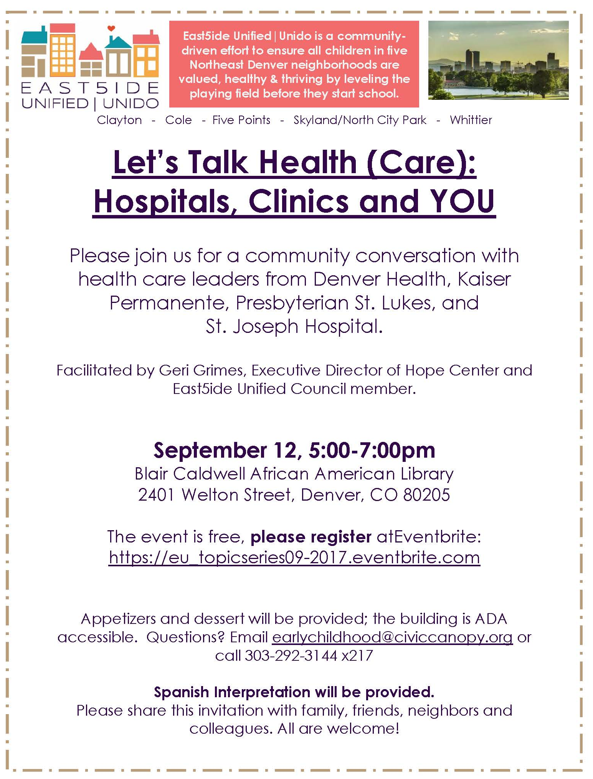
80205 Community Events
Neighborhood Association Meetings
Clayton - 2nd Mondays 5:30pm @ NOLA Voodoo Tavern

Skyland/North City Park - 4th Tuesdays 6:30pm@ Barrett Elem.

Cole - 2nd Thursdays 6:30pm @ St. Charles Rec

Whittier - 3rd Wednesdays 6:30pm @ Whitter Community Center

Curtis Park Neighbors (Five Points) 1st Thursdays 6:30 @ 711 Park Ave

Five Points has a business Assoc. https://www.fivepointsbiz.org/

To receive ongoing updates and information on East5ide Unified, earlychildhood@ civiccanopy.org and be added to the email list!
Also find us on Facebook!
East5ide Unified/Unido believes that it takes a village to raise a healthy child and that it takes an engaged and empowered community to raise a healthy village. Please join us as we continue to build unity across struggles, collaboration across sectors and connections across efforts.
“What can we do today so that tomorrow we can do what we cannot do today?” Friere

