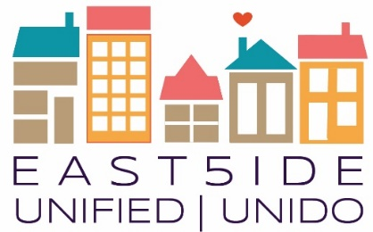
East5ide Unified|Unido is a community-driven effort to ensure all children in five Northeast Denver neighborhoods are valued, healthy & thriving by leveling the playing field before they start school.

Clayton ● Cole ● Five Points ● Skyland/North City Park ● Whittier

Putting Power Behind Your Message
Intentionally Framing for Change, Part 1

Join a training focused on shifting the way we talk about social change issues, particularly around adversity and resilience for children and communities, to change the narrative and shift community thinking toward supporting all children and families.

This training will be part one of a series engaging the 80205 community. Part 1 will be geared specifically toward the East5ide Unified Council, Work Groups, and Street Teams.

- Recognize existing patterns of public thinking about early childhood development, mental health, and early adversity.
- Gain tools and approaches to leverage this research to shift the narrative toward broad community support and a commitment to children and families.
- Become immersed in the research-based frames and metaphors supporting the development of Colorado’s Early Childhood Shared Message Bank

Date, Time, & Location
Tuesday, July 11 from 5:30 PM-7:30 PM
Tramway Nonprofit Building, Training Room

Questions? Email earlychildhood@civiccanopy.org or call (303)292-3144 ext. 217. Visit our website at www.east5ideunified.org.

