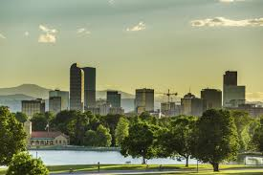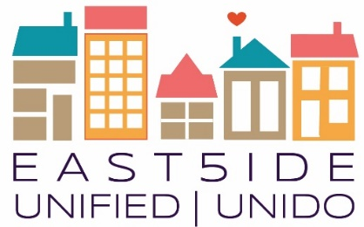

**East5ide Unified|Unido is a community-driven effort to ensure all children in five Northeast Denver neighborhoods are valued, healthy & thriving by leveling the playing field before they start school.**

|  |  |  |
| --- | --- | --- |
| |  |  | | --- | --- | |  |  | |

Clayton ● Cole ● Five Points ● Skyland/North City Park ● Whittier

**The Power of Connectedness**: Connection begins with our relationship to parents and family - but does not end there. A healthy community is a connected one. Children, adults, families, organizations, businesses and neighborhoods require connection to self, to one another and to culture to truly thrive. To build interdependent connections will take all of us, and begins with each one of us.

**Work Group Meetings**

These meetings are for those who want to roll up their sleeves and take action rather than just talking. We dig into strategy, objectives, results, & possibilities in each of the following areas. Your voice is needed & welcome:

**Residential Outreach:** Every 2nd Tuesday @ 5:30-7:30 3532 Franklin Street, we will be placing signs on the doors to direct you to the room we are in.

**Business and Organization Outreach:** Every 2nd Tuesday @ 5:30-7:30 3532 Franklin St - We will be placing signs on the doors to direct you.

**EU Council Meetings:** July 18, 5-7pm @ 3532 Franklin Street – these meetings are open to the public to observe!

**2017 Topic Series**

**June 17th:** Juneteenth Community Convos: Why Are We Here and Where Are We Going?

**July 11th:**  Outreach Workgroup Shared Messaging Training. 5:30 pm – 7:30 pm at the Tramway

**June 18th, noon- 4pm :** REACH for Peace Fatherhood BBQ and Fatherhood Awards: Unified Event @ McGlone Elementary – Montebello

**July 31st:** - Education - What parents really need to know: Building Voice Coalitions

**August 21st 6-8pm:** Arts, Athletics, & Programs: How we integrate for well-rounded kids

**September 18th 6-8pm -** Community Wide Partnership with 80205: One Healthy Generation

**October 16th 6-8pm:** Black and Brown: A House NOT Divided in Common Struggle

**November 11th 4-6pm:** Welcome White People: Economics, Separating Race and Poverty

**December 9th 1-4pm:** Community, Family, & Faith Celebration

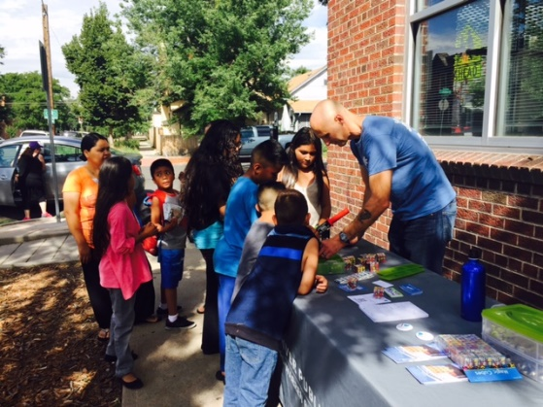



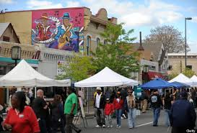**80205 Community Events**

**Neighborhood Association Meetings**

Clayton - 2nd Mondays 5:30pm @ NOLA Voodoo Tavern

Skyland/North City Park - 4th Tuesdays 6:30pm@ Barrett Elem.

Cole - 2nd Thursdays 6:30pm @ St. Charles Rec

Whittier - 3rd Wednesdays 6:30pm @ Whitter Community Center

Curtis Park Neighbors (Five Points) 1st Thursdays 6:30 @ 711 Park Ave

Five Points has a business Assoc.

https://www.fivepointsbiz.org/

**80205 Father’s Day Breakfast**

Come celebrate the fathers in our lives! Join us 8:30am to 10:30am on 6/18 we will eat, bring **MenUp** and honor Fathers as **F.A.M.I.L.Y.**

@ New Hope Baptist Church, 3701 Colorado Blvd

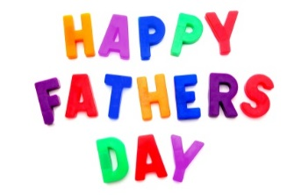

**80205 Dialogue on “Dog Whistle Politics” Race, Power, Politics**

June 27th 5-7:30 pm at Christ Lutheran Church 3460 Humboldt

**80205 Unity Summit**

**August 5th, 2017 9am—1pm**

This Summit is being developed to bring together voice from EVERY Stakeholder Group in 80205 to convene a common vision and goals for sustainably moving forward in a way where 80205 consistently works WITH each other moving forward for our children’s future.

**To receive ongoing updates and information on East5ide Unified, Email** [**earlychildhood@civiccanopy.org**](mailto:earlychildhood@civiccanopy.org) **and be added to the email list!**

**Also find us on Facebook!**



East5ide Unified/Unido believes that it takes a village to raise a healthy child and that it takes an engaged and empowered community to raise a healthy village. Please join us as we continue to build unity across struggles, collaboration across sectors and connections across efforts.

“*What can we do today so that tomorrow we can do what we cannot do today*?” Friere